Tea Collector Data Management System
Case Study: Sorwathe Ltd

Name of the Student:
Keshwani Nazir
________________________

Registration number:
W/BIT/21/09/15480
__________________________

Under the guidance and supervision of Jean Claude NTIRANTA

Research is submitted to:
University of Kigali in Partial Fulfilment of the requirements for the award of Bachelor’s Degree in Information Technology (BIT).

Department of Bachelor of Information Technology

Year of submission 2026

DECLARATION
I hereby declare that this research is my own work. I have to the best of my knowledge acknowledged all authors or sources from where I got information. I further declare that this work has not been submitted in any College or institution for the award of a degree or any of its equivalents.

Prepared by: Keshwani Nazir
Signature: ………………
Date: September, ……..., 2026

APPROVAL
This is to acknowledge that Keshwani Nazir with Registration Number: W/BIT/22/01/15480, wrote this research: Tea Collector Data Management System for collection Centers under the supervision of Jean Claude NTIRANTA, Department of Bachelor of Information Technology (BIT), in partial fulfillment for the award of Bachelor’s Degree with Honors in Information Technology.

Signature: ….………………………… Date: September, 2026
Jean Claude NTIRANTA
Supervisor

DEDICATION
I dedicate this research to God Almighty, my creator, my strong pillar, my source of inspiration, wisdom, knowledge and understanding. He has been the source of my strength throughout this program and on His wings only have I soared. I would also like to dedicate this research project to my family for their continuous prayers towards me. This research project is also dedicated to my best friends, and classmates. We shared many things in life. This research project is also dedicated to my lovely Lecturer as well as my Supervisor Jean Claude NTIRANTA, he helped me many things in this research project. All the people who helped me to reach this academic level, particularly the Government of Rwanda, my Lecturers, this research project is dedicated to them.

ACKNOWLEDGMENTS
I would like to express my sincere gratitude to all the individuals and organizations who have contributed to the development of this research on enhancing the Tea Collector Data Management for Tea collection Centers. Their valuable insights, guidance, and support have been instrumental in shaping the direction and objectives of this study.
First and foremost, I extend my deepest appreciation to my supervisor Jean Claude NTIRANTA, whose expertise, guidance, and encouragement have been invaluable throughout the research process. Their insightful feedback and constructive suggestions have helped refine the and ensure its relevance and rigor.
I extend my thanks to the participants of this study, including manage, collectors, farmer, employees, supervisors, and other key stakeholders, who have generously shared their time, experiences, and perspectives. Their active involvement in interviews, surveys, and other data collection methods has enriched the research with valuable insights into the current Tea Collector Data Management for Tea collection Centers and the potential for improvement.
Furthermore, I would like to acknowledge the authors and researchers whose work I have reviewed in the literature review section. Their contributions have laid the foundation for this research, and their insights have significantly influenced the direction and scope of this study.
Lastly, I would like to express my gratitude to my friends and family for their unwavering support, understanding, and encouragement throughout the research process. Their belief in my abilities and their constant motivation have been pivotal in overcoming challenges and staying focused on the research objectives. While it is not possible to mention everyone individually, please know that your contributions have not gone unnoticed or unappreciated. This research would not have been possible without the collective effort and support of all involved.

TABLE OF CONTENTS
DECLARATION i
APPROVAL ii
DEDICATION iii
ACKNOWLEDGMENTS iv
ABSTRACT viii
List of tables ix
List of figures x
Abbreviation xi
CHAPTER ONE: GENERAL INTRODUCTION AND BACKGROUND TO THE STUDY 1
1.0 Introduction 1
1.1 Background to the study 1
1.2 Statement of the problem. 2
1.3 Objectives of the study 3
1.3.1 General Objectives 3
1.3.2 Specific objectives 3
1.4 Research questions 3
1.5 Significance of the study 4
1.5.1 Personal interest 4
1.5.2 Institutional interest 4
1.5.3 Public interest 4
1.6 Scope of the study 4
1.6.1 Content Scope 4
1.6.2 Geographical Scope 4
1.7 Limitation 5
CHAPTER TWO: LITERATURE REVIEW 6
2.0 Introduction 6
2.1 Definition of key concepts 6
2.1.1 Tea Collection Centre. 6
2.1.2 Tea Collector Data Management System 6
2.1.3 Tea Factory 6
2.1.4 Tea Supply Chain 6
2.2 Review of Related Literatures 7
2.2.1 Empirical review 7
2.2.2 Theoretical Review 10
2.2.3 Summary of the Gap 11
2.2.4 Conceptual framework 12
CHAPTER 3: RESEARCH METHODOLOGY 14
3.0 Introduction 14
3.1 Research design 14
3.2 Population and selection of the sample 15
3.2.1 Population 15
3.2.2 Sampling 16
3.3 Tools for data collection / Instrumentation 17
3.3.1 Interview 18
3.3.2 Observation 18
3.3.3 Documentation 18
3.3.4 Internet Research 19
3.4 Collection of data 19
3.5 Presentation of data and Analysis of data 19
3.6 Validity and Reliability 19
3.6.1 Validity 19
3.6.2 Reliability 20
3.7 Ethical Considerations 20
3.8. Software development model 20
3.8.1 Iterative Model - Design 21
CHAPTER 4: SYSTEM ANALYSIS AND DESIGN 23
4.0 Introduction 23
4.1 Analysis of the Existing system 23
4.1.1 Problem of the Existing system 24
4.2 Description of the Existing Tea Collection Process 24
4.2.1 Demographic Characteristics of the Respondents 25
4.2.1. Demographic Characteristics of the Respondents 25
4.2.2. Effects of the existing tea collection system 25
4.2.3. Impact of the new system (tea collector data management system) 26
4.3. Interpretation of findings and results 27
4.4. Summary 28
4.5. Description of the Existing System 28
4.6. Description of the new System 29
4.6.1. Functional Requirements of the new system 29
4.6.2. Non-Functional Requirements of the new system 30
4.7. Illustration of New system 31
4.7.0. What is UML? 31
4.7.1. Data Flow Diagram (Context Diagram, DFD-Level 0, 1, 2, etc.) 32
4.7.2 Use Case Diagram and sequence Diagrams 34
4.7.3 Data Dictionary 37
4.7.4 Entity Relationship Diagram 42
4.7.5 Physical Data Model 43
Physical Data Model of the system 43
4.8 Architecture design of the new System 44
4.9 Implementation and coding 45
4.9.1 Introduction 45
4.9.2 Description of implementation Tools and technology 45
4.9.3 Screen Shots and Source Codes 49
4.10 Testing 57
4.10.1 Introduction 57
4.10.2 Objective of Testing 57
4.10.3 Unit Testing Outputs 57
4.10.4 Validation Testing Outputs 58
4.10.5 Integration Testing Outputs 58
4.10.6 Functional and system testing Results 59
4.10.7 Acceptance Testing Report 60
CHAPTER 5 CONCLUSION AND RECOMMENDATIONS 61
5.0 Conclusion 61
5.2 Recommendations 61
References 62

ABSTRACT
The Tea Collector Data Management System (TCDMS) for SORWATHE Ltd Tea Collection Centres is a computerized system designed to improve the management of green tea leaves collected from farmers before transportation to the tea processing factory. Tea collection centers play an important role in the tea production process by collecting tea leaves from farmers, recording quantities, managing farmer information, processing payments, and coordinating transportation to the processing factory. Farmers depend on accurate weighing, proper record management, timely payments, and reliable information about their tea deliveries. However, the existing system at SORWATHE Ltd mainly uses manual methods to record and manage tea collection activities. This creates several challenges, including inaccurate data entry, calculation errors, delays in processing information, misplaced or damaged documents, difficulties in retrieving historical records, and delays in preparing reports. The manual system requires employees to use books, paper files, and other physical documents to record information about farmers, tea quantities, collection dates, tea quality, payments, and transportation. As a result, errors can occur when recording farmer identification numbers, quantities of tea, dates, prices, and payment amounts. Paper records may also be lost, damaged, or misplaced, making it difficult to retrieve information when needed. Searching for previous tea delivery records can take a considerable amount of time, especially when many farmers are served by a collection centre. In addition, calculating the total amount of tea supplied by individual farmers or collection centres requires manual work, which increases the possibility of calculation errors. Another challenge is the management of farmer payments. Payments are often calculated manually based on tea quantity, tea quality, and applicable market prices. This may cause delays and errors in payment processing and can lead to disagreements when farmers are unable to verify their delivery and payment records. Farmers may also have limited access to information about their collection history, total quantities supplied, and payment status. Furthermore, the preparation of weekly, monthly, and annual reports requires employees to collect and combine information from different manual records. This process consumes time and may delay management decision-making. Transportation activities are also managed separately, making it difficult to monitor the movement of collected tea from collection centres to the SORWATHE processing factory. To solve these challenges, the proposed Tea Collector Data Management System (TCDMS) will provide a centralized computerized platform for managing tea collection activities. The system will securely store information about farmers, tea collection centres, tea collection records, tea quantity, tea quality, collection dates, payments, transportation, users, and reports. Authorized users will be able to electronically record tea deliveries, update farmer information, retrieve previous collection records, and generate accurate reports. The system will also automatically calculate farmer payments based on the recorded tea quantity, quality, and applicable prices, thereby reducing calculation errors and improving the efficiency of payment processing. The system will provide farmers with access to relevant information about their tea deliveries, collection history, and payment status according to their authorized access. This will improve transparency, communication, and trust between farmers and SORWATHE Ltd. The system will also support transportation management by recording vehicle and transportation information, monitoring tea movements, and assisting in the scheduling of transportation activities. This will help ensure that collected tea is transported efficiently from collection centres to the processing factory and reaches its destination in good condition. By integrating farmer management, tea collection management, payment management, transportation management, reporting, data security, user management, and access control into one computerized platform, the TCDMS is expected to reduce errors, minimize paperwork, improve data retrieval, increase payment accuracy, strengthen transportation monitoring, and improve the overall efficiency of tea collection operations. The system will support better financial management, transparency, accountability, and decision-making at SORWATHE Ltd Tea Collection Centres in Kinihira, Rulindo District, Rwanda.

List of tables
Table 1: Sample Size Determination 17
Table 2: Gender of Respondents 25
Table 3: Respondents Rating of the Existing Tea Collection System 26
Table 4: Respondents Views on the Tea Collector Data Management System 27
Table 5 manager and admin information 38
Table 6 collection centers 38
Table 7 farmers 39
Table 8 tea collections 39
Table 9 Vehicles 40
Table 10: Transport schedules 40
Table 11 cooperatives 41
Table 12 Vehicles 41
Table 13: inventory 41

List of figures
Figure 1 Conceptual framework 13
Figure 2 iteration model (Javatpoint, 2026) 21
Figure 3: Context Diagram (DFD - Level 0) of the System 33
Figure 4: Data Flow Diagram Level 1 of the System 34
Figure 5: Use Case Diagram of the System 35
Figure 6: Sequence Diagram of the System 37
Figure 7 Entity Relationship Diagram 43
Figure 8: Physical Data Model of the system 44
Figure 9 Architecture design of the new System 45
Figure 10 Register User or Manager by Administrator 51
Figure 11 Login users form 52
Figure 12 manage farmers 52
Figure 13 Collection manage 53
Figure 14 payment manage and status 53
Figure 15 tea collection inventory 54
Figure 16 manager report 54
Figure 17 New record of Tea collection page by collector 55
Figure 18 Transport schedule 55
Figure 19 Transport new schedule 56
Figure 20 manager report 56
Figure 21 View and calculate payment by accountant 56
Figure 22 reporting by accountantt 57

Abbreviation
LTD: Limited
BIT: Bachler Information Technology
ICT: Information Communication Technology
IMS: Integrated Management System
SDLC: Software Development Life Cycle
TCDMS: Tea Collector Data Management System

CHAPTER ONE: GENERAL INTRODUCTION AND BACKGROUND TO THE STUDY

1.0 Introduction
Today, technology is the most important thing in many domains such as education, hospitals, companies and help business and organizations for managing controlling processing and sharing information all over the world via the network. Involvement of technology in those sectors increase productivity and improve efficiency. Today different applications are being development to handle activities by changing from manual system to computerized system where computers and smart phones contributes the important role of processing and storing information.
Even though the use of ICT in increased in this century in the world even our country, there are some activities in business where the manual system of keeping and processing information is still used resulting the insecurity and the loss of information and taking long time as well. (Karunarathna, 2025)

1.1 Background to the study
Tea is one of the important agricultural products in Rwanda and contributes to the livelihoods of many farmers and to the country's economy. Tea production involves several activities, including tea cultivation, harvesting, and collection, transportation, processing, packaging, and marketing. Among these activities, tea collection is an important stage because freshly harvested green tea leaves must be collected, recorded, weighed, and transported to the processing factory within an appropriate period. Effective management of tea collection information is therefore important for ensuring accurate records, timely payments, efficient transportation, and good relationships between tea companies and farmers.
SORWATHE Ltd is a tea company operating in Rwanda and has been involved in the country's tea industry since 1975. Over the years, the company has developed its tea production and processing activities and produces different types of tea, including black tea, green tea, and organic tea. Its tea products are supplied to the Rwandan market and international markets. SORWATHE works closely with small-scale tea farmers who supply fresh green tea leaves to collection centres. The collected tea leaves are then transported from the collection centres to the processing factory for further processing. Through its activities, the company is also involved in supporting farmers, workers, environmental sustainability, and the development of communities surrounding its operations. (sorwathe, about, 2024)
With all the good things SORWATHE does collecting tea is still a bit of a problem. The people who collect tea have to write down a lot of information by hand which takes a time and can lead to mistakes. It is hard to keep track of things like how tea each farmer brings how much they get paid and when the tea is moved. This can cause problems. Make it harder for the tea collectors and farmers to work together.
The Tea Collector Data Management System is a plan to use computers to manage how tea is collected at SORWATHE. The system will keep track of the farmers and how tea they bring. It will also calculate how much they should be paid based on things like the quality of the tea and the price it sells for. The system will help make reports and plan how the tea is moved around. This will make things more transparent help people get more work done and reduce costs. It will also help people make decisions, about the tea industry.

1.2 Statement of the problem.
Although SORWATHE Ltd. Has tea farming and processing facilities some tea collection center activities are still managed using record-keeping methods. This way of working leads to data entry losing records delays in processing payments and trouble tracking tea collected from each farmer. Managers also spend a lot of time making reports, weekly reports, monthly reports and annual reports because the data is spread out in record books and files.
The manual system also makes it hard to keep an eye, on tea quality, transportation schedules, and inventory and payment status. Farmers cannot easily check their collection records or payment information which makes things less clear and lowers trust. These problems hurt how well the company works, raise costs and slow down decisions. So there is a need to create a Tea Collector Data Management System that makes record management better payment processing faster reporting easier and communication between tea collection canters and farmers more direct.

1.3 Objectives of the study

1.3.1 General Objectives
The general objective of this study is to develop a computerized Tea Collector Data Management System for collection center that improves the management of tea collection, farmer information, payment processing, reporting, and transportation activities at SORWATHE tea collection centers.

1.3.2 Specific objectives
The specific objectives of the study are:
- To describe the functional and user requirements for the Tea Collector Data Management System, including user roles, authentication, and the information needed to manage tea collection, farmers, payments, and transportation.
- To design and develop a user-friendly Tea Collector Data Management System to enable authorised users to securely login and efficiently record, process and manage data on tea collection, farmers and transportation.
- To develop reporting and data management functionalities for the Tea Collector Data Management System to improve data accuracy, security and integrity and generation of daily, weekly, monthly and annual reports.Switch to the A

1.4 Research questions
This research is based on the following questions:
- What are the requirements of farmers, tea collectors, and managers for an effective Tea Collector Data Management System?
- How can the Tea Collector Data Management System improve the recording and management of tea collection, farmer, payment, and transportation information?
- How can the Tea Collector Data Management System help farmers, collectors, and managers reduce errors, access accurate information, and generate timely reports?

1.5 Significance of the study

1.5.1 Personal interest
Surely, the developments of this project strongly enabled the researcher to research and apply deeply different programming languages acquired during his university studies. Finally, when completing this research project successfully, the researcher will be awarded a Bachelor’s degree in Information Technology.

1.5.2 Institutional interest
The study will benefit the University by serving as reference material for future researchers and students interested in agricultural information systems and management information systems.

1.5.3 Public interest
The system will benefit tea collection centers, tea farmers, managers, and other stakeholders by: Improving the management of tea collection records. Providing secure storage of farmer and payment information. Reducing errors in payment calculations. Improving transparency between farmers and tea collection centers. Generating timely reports for management decision-making. Improving transportation planning and operational efficiency.

1.6 Scope of the study

1.6.1 Content Scope
The study focuses on developing a Tea Collector Data Management System capable of managing farmer registration, tea collection records, payment processing, transportation scheduling, report generation, and secure data storage. The system will improve the management of tea collection activities from the collection center to the processing factory.

1.6.2 Geographical Scope
The study is conducted at SORWATHE Ltd. in Rwanda, with particular emphasis on its tea collection centers. The developed system can later be implemented in other tea collection centers across the country.

1.7 Limitation
The study encountered several limitations during the research process, including: There is access to confidential information about the organization. There is not time available to do the research and develop the system. There are problems when collecting data. There is not research that is specifically about tea collection data management system. It is hard to get answers from some people because they are very busy, with their work. Despite these limitations, appropriate research methods were applied to ensure that reliable and accurate information was collected for the successful development of the Tea Collector Data Management System

CHAPTER TWO: LITERATURE REVIEW

2.0 Introduction
A literature review is a comprehensive examination of existing knowledge, theories, research findings, and methodologies related to a particular topic. It enables the researcher to understand previous work, identify research gaps, and establish the foundation for the current study. This chapter reviews literature related to tea collection management systems, tea production, computerized information systems, and tea supply chain management. It also defines key concepts used throughout the study and examines previous studies relevant to the development of a Tea Collector Data Management System.

2.1 Definition of key concepts

2.1.1 Tea Collection Centre.
A tea collection centre is a place where green tea leaves picked by farmers are brought in weighed noted down and readied for moving to a tea processing factory. Tea collection center’s act as the connection between small scale tea farmers and tea processing factories by making sure that tea leaves are treated well and recorded correctly before they are processed. (teaboard, 2023)

2.1.2 Tea Collector Data Management System
A Tea Collector Data Management System is an information system made to handle tea collection tasks in an electronic way. The system keeps farmer details tracks tea deliveries figures out payments creates reports handles transportation plans and offers keeping of tea collection information. These kinds of systems make the work easier more open and more correct in tea collection centres.

2.1.3 Tea Factory
A tea factory is big building where green tea leaves are turned into tea products, like black tea, green tea orthodox tea, oolong tea and special teas. Tea factories get tea leaves from collection centres work on them using set up methods put the goods into packages and send them to global markets. (Naeb, 2025)

2.1.4 Tea Supply Chain
The tea supply chain refers to all activities involved in tea production, beginning with cultivation, harvesting, collection, transportation, processing, packaging, storage, marketing, and distribution to consumers. Efficient management of the tea supply chain ensures product quality, timely delivery, and improved profitability. (Piazza, 2025)

2.2 Review of Related Literatures

2.2.1 Empirical review
Several studies have demonstrated that computerized information systems significantly improve agricultural management by reducing manual work, minimizing errors, and increasing productivity. Digital record management allows organizations to maintain accurate information while supporting faster decision-making through automated reporting.
The tea industry has increasingly adopted digital technologies to improve the management of tea collection activities. Researchers have found that electronic collection systems reduce paperwork, improve transparency in farmer payments, and provide accurate production statistics. Computerized systems also improve communication between tea factories and smallholder farmers while enhancing operational efficiency.
SORWATHE Ltd., established in 1975, is among Rwanda's leading tea producers and one of the country's pioneers in sustainable tea production. The company produces high-quality black, green, orthodox, organic, oolong, and specialty teas for both domestic and international markets. SORWATHE collaborates with thousands of smallholder tea farmers who supply green tea leaves through collection centres. The company has received several international certifications, including Fair Trade Certification, Rainforest Alliance Certification, and membership in the Ethical Tea Partnership. It also promotes environmental conservation, workers' rights, education, healthcare, and community development. (Agri-plantation, 2026)
Although SORWATHE has modern tea production facilities, tea collection activities in many centres still involve manual procedures for recording farmer information, weighing tea, calculating payments, and preparing reports. Manual operations increase the risk of inaccurate records, delays in payment processing, misplaced documents, and inefficient transportation planning. These challenges justify the need for a computerized Tea Collector Data Management System.
Several tea-producing countries, including Kenya, India, Sri Lanka, and Rwanda, have introduced digital management systems to improve tea collection and traceability. These systems allow collection centres to capture tea collection data electronically, monitor production performance, automate farmer payments, and generate management reports. Studies indicate that computerized systems improve accountability, reduce operational costs, and strengthen relationships between farmers and tea processing companies. (sorwatheltd, 2024)

2.2.1.1 Tea supply chain, Environmental sustainability challenges, and Divergent economies.
Tea production is one of the most important agricultural industries in the world and plays a major role in global agriculture and trade. As the tea industry continues to grow, there is increasing pressure to make its supply chains more environmentally sustainable. This is especially important for China, the world's largest tea producer, and Kenya, one of the leading exporters of black tea.
Although China and Kenya differ in their environmental, economic, social, and cultural conditions, both countries face challenges in making tea production more sustainable. Their approaches to environmental sustainability are different. China focuses on technological innovation and strict government policies to reduce pesticide use and improve production efficiency. Kenya, on the other hand, relies on international partnerships and local initiatives to address climate change and food insecurity.
In both countries, environmental sustainability is often given less priority than economic development and food production, which are essential for national growth. Achieving a balance between protecting the environment and supporting economic progress requires stronger policies and long-term planning. The main challenge is to promote sustainable tea production while ensuring economic growth and food security in these important tea-producing countries. (Piazza, 2025)

2.2.1.2 Effect of Inventory Control Systems on Operational Performance of Tea Processing Firms: A Case Study of Gianchore Tea Factory, Nyamira County, Kenya

Literature on supply chain management and firm's operational performance indicate increased need for improved quality of operations. Tea processing firms face problems of fluctuating inventories, inaccurate forecasts and low utilization of inventories due to inadequate coordination of operations. The existing literature indicated that not all inventory control systems were necessarily best for application in given firms. The purpose of the study was to assess the effect of inventory control systems on operational performance of tea processing firms with a focus on Gianchore tea factory. Objectives of the study were to: Determine the effect of material requirement planning on operational performance, establish the influence of continuous replenishment on operational performance, establish the extent to which distribution resource planning influence operational performance and the effect of vendor managed inventory on operational performance of Gianchore Tea Factory. The study target population was 119 respondents consisting of one (1) factory manager, sixteen (16) middle level managers, thirty six (36) factory supervisors and sixty six (66) employees working at Gianchore tea factory. Purposive sampling and stratified random sampling techniques were applied to select a sample of fifty five (55) respondents for this study. The main data collection instrument was a structured questionnaire. Quantitative data was analyzed using descriptive and inferential statistics, and regression analysis to assess the association between the variables in the study. The findings of this study are expected to be beneficial to the management of tea processing firms to improve their operational performance and also inform policy makers. The study findings will contribute towards academic paradigms and fill the gap between researched work and unresearched areas. The expected outcome in this study is that there can be a significant correlation between the use of inventory control systems and operational performance of a tea processing firm. (Mogere, 2013)

2.2.1.3 Data-driven smallholder tea production in Uganda
A spatial data management system to profile tea farmers and map tea plots among members of the Igara Tea Growers Factory (IGTF) in Uganda has led to increased access to financial services for producers, and higher repayment rates for input loans. An immediate impact has been increased productivity and a dramatic fall-off in the practice of side-selling – so much so that other tea companies are now considering adopting the model. (Igara Tea Growers Factory, 2018)

2.2.1.4 Evaluation of Waste Management Systems In A Kenyan Tea Factory: A Case Study Of Maramba Tea Factory In Kiambu County
This paper evaluates the effectiveness of waste management systems in Maramba Tea Factory in Kiambu kenya County, Kenya. Performance of the already existing systems is therefore critical in sustaining our environment. Tea processing generates different types of wastes. A waste management system design should at least begin from a clear characterization of these wastes, the quantities and qualities of the wastes and identification of sources. This study attempted to bring these challenges to the fore. It evaluated the waste management systems for Maramba Tea factory in Kiambu County, Kenya. Primary data and secondary data, purposively and Convenience sampling techniques, Benchmarking evaluation technique were utilised. The types of wastes identified were organic solid wastes, inorganic solid wastes, Liquid wastes and Thermal wastes. The quantities of wastes were determined by weighing. (Kola, 2020)

2.2.1.5 Tea Collector: Web Based Data Tracking Solution for Tea Smallholders
The sustainability of a tea factory also depends on the trustworthiness of the data collection and finance management. Collection of tea leaves and tea processing are the main two processes done by a tea factory. In the process of tea collection, they must handle a large set of data about the tea collection, selling and calculating payments. Data processing and summarizing can be identified as critical process because these summarizations finally sent to the factory for further analyzes. All these documentation processes are still handled mostly in a manual way. This manual process may lead to malpractices sometimes. So, there is a need to develop an easy way to manage all the documentation processes online. In this specific research, our idea is to implement a web application with features like adding, updating, and deleting data with a generation of summary reports. The main reason we need to shift from a normal manual process to an online managed process is that they can consume their time by managing the data more secure and trustworthy way. We have implemented this by using MERN stack as the technology where we use react.js for the frontend and express.js for the backend developments. We used MongoDB as the database and Heroku to host the application. (G.K.A, 2022)

2.2.2 Theoretical Review
The Tea Collector Data Management System is based on the Management Information System (MIS) Theory. This theory says that organizations do better when they collect, process, keep and share information in a good way to help managers make better choices. A computerized information system helps organizations handle a lot of data while keeping it correct and safe.
Another idea that supports this research is the Systems Theory. This idea sees an organization as a group of parts that work together to reach the goal. In tea collection centres, farmers, people who check the tea people who move the tea, accountants and factory managers all need each other to make things work. Putting these jobs into one system makes it easier to work together talk to each other and do a better job.
Database Management Theory also supports this study by focusing on keeping all the data in one place. Of using many paper records a computerized database holds all the information about farmers the tea they collect the money they get when the tea is moved and reports. This makes sure the data is the same cuts down on repeating the same information and lets people find the information they need quickly.
The system that is being suggested brings all these ideas together by offering data handling, automatic math making reports and better talking between everyone who is part of the tea collection work.

2.2.3 Summary of the Gap
The studies that have been looked at show that computerized information systems make work faster make data more correct make things more clear and help managers make choices in the farming business. Previous studies mostly look at how tea's made how good the tea is, how it is kept from hurting the environment and how well it sells to other countries. Even though some groups have used tools in making tea not much research has looked at computerized ways to manage tea collection centres, especially in Rwanda.
Most of the systems focus on making tea or checking how the tea moves but don’t help much with signing up farmers recording the tea they collect calculating money automatically managing how the tea is moved and making reports all, in one place. Paper records are still used a lot in tea collection centres leading to payments wrong records, bad communication and not working well when it comes to reports.
The Tea Collector Data Management System fills these gaps by putting together managing farmers recording the tea they collect handling payments, planning when the tea is moved making reports and keeping data safe in one system. The system is expected to make things clearer work better handle money better and help people talk better between tea collection centres and tea farmers while helping managers make choices at SORWATHE Ltd.

2.2.4 Conceptual framework
A conceptual framework is like a map that shows how different things are connected in a study. It helps the person doing the research understand the problem they are trying to solve and figure out how to get to the answer. The framework shows how all the different parts of the study work together to get the desired results. It also helps explain how information moves through the system and what the outcomes will be.
For this study we made a simple model to show how using a computer system to manage tea collection data at SORWATHE Ltd can make things better. The framework points out the things that need to happen for tea collection to work well. (C. Umutoni, 2023)
The conceptual framework for this study says that the important things that can be changed are things like signing up farmers keeping track of tea collection checking the quality of the tea handling payments, managing transportation making reports and keeping the database up, to date. The computerized Tea Collector Data Management System takes these things. Uses them to make good things happen like making sure the data is accurate paying people on time being transparent planning transportation well keeping data safe helping tea collectors and farmers talk to each other making good decisions and getting more work done. (SORWATHE, 2026)

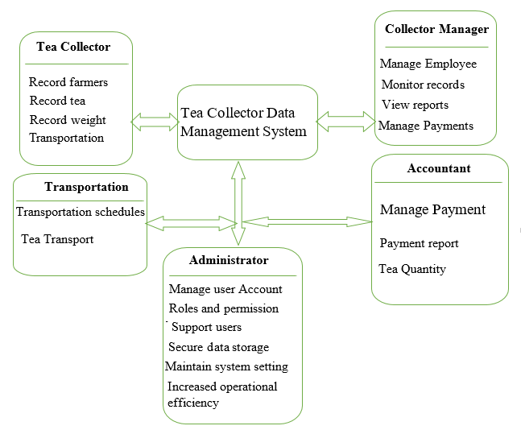
Figure 1 Conceptual framework

CHAPTER 3: RESEARCH METHODOLOGY

3.0 Introduction
This chapter will present detailed idea about how the research will be conducted. The researcher is going to describe and justify what methods that applied to answer the research questions. This includes the research design, Population and sample selection methods, and data collection technique, Presentation of data and Analysis of data. At the end of this chapter also validity and reliability issues will be discussed to follow the quality standards of the research and ethical consideration.

3.1 Research design
The Tea Collector Data Management System for SORWATHE Ltd is what this study is about. It looks at how the Tea Collector Data Management System for SORWATHE Ltd. Works especially when it comes to collecting, storing, managing and getting back information about tea collections. The new system wants to make sure that important papers like farmer details tea collection records, payment information, employee information and transaction history are kept safe and can be found easily when needed.
The Tea Collector Data Management System for SORWATHE Ltd. Is supposed to make the old manual system better by using computers to keep records keep data safe and make tea collection operations more efficient. To do this the person studying this used surveys and interviews to understand how things are done now what problems there. What is needed to make a good Tea Collector Data Management System for SORWATHE Ltd. They talked to people who collect tea, managers, employees and some farmers to get information about collecting tea paying people making reports and managing data.
This study looked at how tea collection activities managed now at SORWATHE Ltd. And what technology can be used to make a web-based system. The study thought about things like keeping data safe what users need how the system works, managing the database and making reports. It also looked at the problems with keeping records by hand like losing data having records taking too long to report and having trouble tracking information about tea collections.
The main goal of this study is to make a web-based application that helps SORWATHE Ltd. Manage tea collection activities well. The new Tea Collector Data Management System for SORWATHE Ltd. Will be in charge of things like signing up farmers recording tea collections calculating payments managing employees and making reports. By keeping all the information in one database the Tea Collector Data Management System for SORWATHE Ltd. Will make things more accurate transparent safe and help with decision making, at SORWATHE Ltd.

3.2 Population and selection of the sample

3.2.1 Population
A population is the entire group of individuals, objects, or units of analysis about which a researcher intends to collect information and measure variables. The population may include employees, managers, farmers, tea collectors, or other stakeholders related to the area of study. SORWATHE Ltd. is a leading tea farm and factory in Rwanda that processes tea produced from its own estate and from smallholder tea farmers. The company processes tea grown on its own farm of 284 hectares, as well as tea supplied by two Rwandan cooperatives: 1,226 hectares managed by Assopthe Cooperative and 355 hectares managed by Hillside Organic Tea Cooperative. These cooperatives represent more than 4,700 and 2,000 smallholder tea farmers respectively, who supply green tea leaves to SORWATHE for processing. Currently, SORWATHE Ltd. employs over 2,500 Rwandans working in its factory and tea farms and produces approximately 7.7 million pounds of high-quality black, green, oolong, organic, and specialty teas annually for local and international markets. (Research, 2012) (sorwathe, About, 2026)
For this study, the target population consists of individuals directly involved in tea collection and data management activities at SORWATHE Ltd. This includes tea collectors, tea collection centre supervisors, managers, accountants, transport officers, and other employees responsible for recording, managing, and reporting tea collection information. These participants were selected because they have direct experience with the existing tea collection processes and can provide important information required for developing the Tea Collector Data Management System. The study population does not include all employees and farmers associated with SORWATHE but focuses on the specific group involved in tea collection operations and information management. The selected respondents will provide data about the current system, challenges faced, and the requirements needed to develop an effective computerized Tea Collector Data Management System. (sorwatheltd, 2024)

3.2.2 Sampling
In research a sample is a group of people chosen from a group to stand in for that bigger group when information is being collected. A good sample lets the person doing the research make decisions that're correct and apply what they find out to the whole group. Since it is usually not possible to get information from every person in the group because it would take too much time cost too much money and be hard to reach everyone a sample is used to get good information quickly. This study was done at SORWATHE Ltd., a tea farm and factory that was started in 1975. The company has than 2,500 people from Rwanda working for it at the factory and on the tea farms and it works with more than 6,700 small tea farmers through the Assopthe Cooperative and Hill Side Organic Tea Cooperative. These tea farmers give SORWATHE tea leaves that are then made into very good black, green, oolong organic and special teas. The research looked at the people who work with tea collection and managing information like the people who collect tea the supervisors, the accountants, the transport officers, the storekeepers and the managers. These people were chosen because they know a lot, about the tea collection system and can say what is needed for the new Tea Collector Data Management System that is being for SORWATHEs tea collection system. (sorwathe, About, 2026)
The people in this study were 2,500 employees who worked at SORWATHE Ltd. It was not possible to get information, from every employee. So a group was chosen. The group was selected using Slovins formula. The margin of error was 5%. The confidence level was 95%.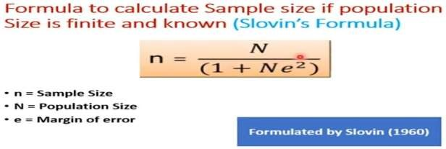
By using the above formula, I knew the number of citizens to be interviewed.
By using Slovin’s formula on population of Tea collection Centers Sample Size will be: n=2500/ [1+ (2500*0.05²)] = 345 respondent, where N=2500 and e=0.05
In sampling, I used “simple random sampling” as a technique of sampling. Because this technique gives equal chance to participants of being selected from population under study.

3.2.2.1 Sample size table

Category of Population | Population(N) | Sampling Technique | Sample Size(n)
Tea collectors | 1860 | Simple random sampling | 256
Tea collection centre supervisors | 150 | Simple random sampling | 21
Accountants | 50 | Simple random sampling | 7
Storekeepers | 150 | Simple random sampling | 21
Transport officers | 150 | Simple random sampling | 21
Managers | 40 | Simple random sampling | 6
Other employees involved in tea collection/data management | 100 | Simple random sampling | 13
Total | 2500 | Simple random sampling | 345
Table 1: Sample Size Determination

3.3 Tools for data collection / Instrumentation
The research design for the Tea Collector Data Management System employed different data collection methods to gather accurate and reliable information. These methods included interviews, questionnaires, observations, and document review. Interviews were conducted with tea collection center managers, tea collectors, accountants, transport officers, and selected tea farmers to obtain detailed information about the current tea collection process, existing challenges, and system requirements. Questionnaires were distributed to employees and tea farmers to collect data from a larger number of respondents regarding tea collection, payment processing, record management, and reporting practices. Observation was used to study the existing procedures of tea collection, weighing, recording, payment processing, and transportation at the collection center. In addition, relevant documents such as tea collection records, payment reports, and operational reports were reviewed to better understand the current system and identify areas that require improvement. These data collection methods enabled the researcher to gather comprehensive information for the successful development of the Tea Collector Data Management System.

3.3.1 Interview
By interview, interviewer supposes to meet and converse with more than two people in order to get some information on behalf of interviewee. With this technique, I collected data from different people including employee, manager, store keeper and data manager.
Interview Questions are: Name, Gender, Age
What are the problems existing in Tea Collector Data Management System for Tea collection Centers? Did you ever computerized data management system?
To what extent would the use of a computerized Tea Collector Data Management System improve the management of tea collection activities?

3.3.2 Observation
This technique has served the researcher as a witness for knowing really what is done in the field. With this method I referred to the events or works I ever saw in last time related to Tea Collector Data Management System for SORWATHE Ltd model.

3.3.3 Documentation
This technique helps in defining technical terms which are specific that will be used throughout the course of this project. It is a process of searching in books or other publications from various institutions to find data that are supposed to be useful for subject under the study. This served the researcher to read, to collect, to analyze and to capture the topics related concepts.

3.3.4 Internet Research
This is the practice of using the internet such as World Wide Web (www) to collect information that is relevant to the research or the project. Internet research was the most used data collection technique/method through the course of my research study.

3.4 Collection of data
Data collection for the Tea Collector Data Management System for SORWATHE Ltd includes both primary and secondary sources. Primary data is typically collected through interviews and focus groups with stakeholders, while secondary data is typically collected through reviews, surveys, reports, and research papers. Primary data allows for a more in-depth and personal insight into the Tea collection Centers Tea Collector Data Management System for Tea collection Centers, as well as potential areas for improvement. Secondary data, however, allows for a broader overview of the system, providing greater context and a better understanding of its current state. Both primary and secondary data must be analyzed and interpreted in order to gain a full understanding of the system and its strengths and weaknesses.

3.5 Presentation of data and Analysis of data
The data collected from the various sources is then analyzed to establish a better understanding of the Tea collection Centers Tea Collector Data Management System for SORWATHE Ltd. The analysis involves coding and categorizing of the data in order to identify recurring themes or patterns. Insights and themes that emerge from the data can then be used to formulate conclusions. The analysis of the collected data can be done using a variety of tools and methods, such as statistical analysis, qualitative analysis, and data visualization. Statistical analysis can be used to identify correlations and patterns between different aspects of the data. Qualitative analysis can be used to identify key themes and insights from the data. Data visualization is used to create graphical representations of the data, allowing for easier and clearer understanding.

3.6 Validity and Reliability

3.6.1 Validity
The validity of a Tea Collector Data Management System for SORWATHE Ltd Tea collection Centers depends on the specific features and functions of the system. The system should provide users with the necessary tools and functionality necessary for them to manage products effectively. This would include capabilities such as tracking stock levels, forecasting demand, monitoring production quality, planning promotions, and much more. A good system should also have strong security safeguards in place to protect data and ensure the data is only accessed by authorized personnel. Additionally, the system should be able to integrate with existing systems and provide a high degree of customization to meet the unique needs of the Tea Collector Data Management System for Tea collection Centers. (Shikokoti, 2026)

3.6.2 Reliability
The reliability of a Tea Collector Data Management System for SORWATHE Ltd Tea collection Centers system is determined by its ability to process and store data accurately and dependably. The system should have backup protocols in place that help to ensure any data entry errors are quickly detected and corrected. Additionally, regular system checks should be done to ensure the system is running efficiently and accurately. Finally, providing users with training and support will help to ensure that the system is used correctly and that any issues are quickly addressed and resolved. The information got from the study were accurate and consistent because I used the methods that helped me to get accurate and reliable information such as interview, observation and documentation. (Shikokoti, 2026)

3.7 Ethical Considerations
The ethical considerations for a Tea Collector Data Management System for SORWATHE Ltd should include ensuring that the data collected is used responsibly and in accordance with the wishes of the customers and stakeholders. Additionally, the system should employ data encryption and security measures to ensure the safety of product data. Finally, the system should be designed to ensure compliance with relevant laws and regulations.

3.8. Software development model
Software development models refer to the many approaches or methodologies selected for the project's development in accordance with its goals. A variety of development life cycle models have been developed to achieve various necessary goals.
Each method of software development adopts a different strategy while producing software. For this investigation, the researcher used an incremental/iterative model. The process iteratively improves the evolving versions according to the iterative technique until the full system is created and ready for deployment. A simple implementation of a constrained set of software requirements serves as the foundation.
It starts off with a basic implementation of a constrained set of software needs. A complete set of criteria from the outset is not what an iterative life cycle model seeks to achieve. Instead, only a subset of the software is first described and developed before it is examined to identify any new requirements. This process is repeated to produce a fresh iteration of the software after each model iteration.

3.8.1 Iterative Model - Design
In this Model, you can start with some of the software specifications and develop the first version of the software. After the first version if there is a need to change the software, then a new version of the software is created with a new iteration. Every release of the Iterative Model finishes in an exact and fixed period that is called iteration.
The Iterative Model allows accessing earlier phases, in which the variations are made respectively. The final output of the project was renewed at the end of the Software Development Life Cycle (SDLC) process.
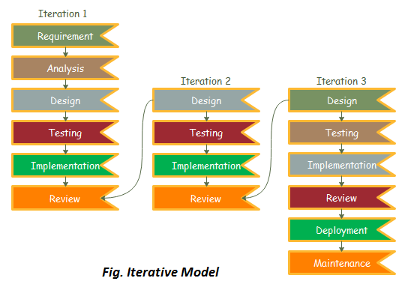
Figure 2 iteration model (Javatpoint, 2026)
Iterative and incremental development combines iterative design, commonly known as the iterative approach, with the incremental build paradigm for development. "During software development, more than one iteration of the software development cycle may be ongoing at the same time." In this incremental model, the full demand is divided across various builds. Each iteration of the development module involves finishing the requirements, design, implementation, and testing phases. Every time a new version of the module is released, its functionality grows. The procedure continues until the whole system is ready in accordance with the specifications. When requirements are thoroughly validated and every iteration of the product is checked and tested against those requirements throughout each cycle of the model, iterative software development lifecycles are most effective.

CHAPTER 4: SYSTEM ANALYSIS AND DESIGN

4.0 Introduction
This chapter presents the analysis and design Tea Collector Data Management System for Collection Centers at SORWATHE Ltd. System analysis is about collecting, looking at and understanding information about the tea collection activities. The goal is to find problems, needs and ways to get results. System design explains how the new system will solve the problems and reach the goals of the study.
The analysis looked at the ways tea collection centers currently find farmers take in and weigh tea leaves write down collection details keep track of farmer information handle payment details plan transportation and make reports. The study also looked at the difficulties that workers and other people involved face when using the manual system. The data that was gathered was. Shown using simple ways to describe numbers and facts. The researcher also used what came from interviews watching what happens, surveys and looking at documents to find out what the new system needs to do and what it needs to be like. For the system analysis and design a set of tools called Unified Modelling Language (UML) was used to show the system. These tools included Data Flow Diagrams (DFDs) Use Case Diagrams, Sequence Diagrams and ideas, for how the database will work. These models help show how people will use the Tea Collector Data Management System and how information will move around inside it. The field data that was gathered was analyzed using Statistical Package for the Social Sciences (SPSS) as a data analysis tool.

4.1 Analysis of the Existing system
The current tea collection activities at SORWATHE tea collection centers depend mainly on work. Farmers bring tea leaves to the centers, where the tea is weighed and details about the farmer and the amount of tea are written down by hand. After that the data can be moved into books, files, spreadsheets or reports for work. The current tea collection process usually has these steps: Verifying tea farmers. Receiving tea leaves from farmers. Weighing the tea supplied by each farmer. Recording the quantity of tea collected. Recording the date and collection center. Recording information about tea quality when needed. Preparing farmer collection records. Preparing data needed for farmer payments. Organizing transport of collected tea to the processing factory. Preparing weekly, monthly and annual reports. Storing collection records for reference. Providing collection information to management for decision-making.
Even though the current system handles the tea collection activities, its reliance, on handwritten and manually kept records makes it hard to store, find, update, analyze and report tea collection information.

4.1.1 Problem of the Existing system
The current tea collection system at SORWATHE tea collection centers faces problems because data is handled manually. First when data is entered by hand mistakes can happen. Numbers for farmer identification amounts of tea dates and collection records might be entered wrong. Left out. These mistakes can make collection reports and payment calculations inaccurate. Second records kept on paper can be lost, damaged, misplaced or destroyed. When information is kept in books and folders it can be hard to find a record when needed. Third looking up past tea deliveries from a farmer can take a time. Staff may need to search books or files before they find the needed information. Fourth to find out how tea each farmer or collection center supplied a lot of manual work is needed. This raises the chance of calculation mistakes. Fifth, making reports takes a lot of time because staff must gather data from records and put it together by hand. This can delay when management can see information. Sixth managers may find it hard to get data about how much tea each collection center has gathered. Without one source of current information decision-making can suffer. Seventh transport details are kept separately from tea collection records. This makes it hard to follow how collected tea moves from each collection center to the SORWATHE processing factory. Finally farmers might not have access to correct data about their own tea deliveries and payment records. Tea Collector Data Management System aims to solve these problems by giving a safe, accurate and easy-, to-use source of tea collection information.

4.2 Description of the Existing Tea Collection Process
The existing tea collection process works like this: A farmer brings green tea leaves to the tea collection center. The tea collector. Confirms the identity of the farmer. The weight of the tea leaves is measured using a weighing scale. The collector writes down the farmer’s identification details. The amount of tea sent by the farmer is written down by hand. Other details about the collection, such as date and time are noted in a notebook or, on paper forms. The collected tea is kept at the center for a while. Trucks or vehicles are arranged to transport the tea to the SORWATHE processing factory. Later all the collected records are gathered to calculate payments and create reports. Managers use the compiled information to keep track of how much tea's being collected and make decisions based on that.
This whole process involves steps where data is recorded by hand and moved from one place to another. Because of this mistakes can happen. Duplicate entries may appear some records might be missing or numbers could be entered wrong. Since everything is done manually it’s hard to see what is happening in time. There is no way to know if a farmer has delivered tea or if the tea has been shipped. This makes tracking difficult. Slows down the overall process.

4.2.1 Demographic Characteristics of the Respondents
The respondents were asked to indicate their gender. The result was then cross tabulated against their designation and the result was as given in the table below:

4.2.1. Demographic Characteristics of the Respondents

4.2.1.1. Gender of the Respondents

The respondents were asked to indicate their gender. The result was then cross tabulated against their designation and the result was as given in the table below:
Gender
 |  | Frequency | Percent | Valid Percent | Cumulative Percent
Valid | Male | 224 | 65.9 | 65.9 | 65.9
Valid | Female | 121 | 34.1 | 34.1 | 100.0
Valid | Total | 345 | 100.0 | 100.0
Table 2: Gender of Respondents

4.2.2. Effects of the existing tea collection system
The following findings relate to the objective of studying the effects and the challenges that come with the existing tea collection data management system at SORWATHE tea collection centers.

4.2.2.1. Responses on the Performance of the Existing System

The respondents were asked to rate the existing system. They had to judge the existing system for recording tea collection information preparing reports retrieving farmer records tracking tea quantities and managing collection information.

How do you rate the existing system for recording tea collection data for preparing reports and, for tracking farmer collection information?
 |  | Frequency | Percent | Valid Percent | Cumulative Percent
Valid | Very Good | 9 | 2.6% | 2.6% | 2.6%
Valid | Good | 17 | 4.9% | 4.9% | 7.5%
Valid | Poor | 65 | 18.4% | 18.8% | 26.8%
Valid | Very Poor | 254 | 71.1% | 71.1% | 100.0%
Valid | Total | 345 | 100.0% | 100.0%
Table 3: Respondents Rating of the Existing Tea Collection System

The findings show that 254 respondents, representing 71.1% rated the existing system as very poor. 65 respondents, representing 18.4% rated it as poor while 17 respondents, representing 4.9% rated it as good. 9 respondent, representing 2.6% rated the existing system as very good.
The findings therefore indicate that most respondents experienced challenges with the existing system, for recording tea collection information retrieving records and preparing reports.

4.2.3. Impact of the new system (tea collector data management system)
The following findings address the goal of studying respondent’s opinions on the proposed computerized Tea Collector Data Management system.

4.2.3.1. Responses on the new system

The he respondents were asked how they would feel if the current manual tea collection system were replaced by the Tea Collector Data Management System, which records tea collection data manages farmer records tracks tea quantities and prepares reports.
How do you feel about implementing the Tea Collector Data Management System to record tea collection data generate reports and track collection information?
 |  | Frequency | Percent | Valid Percent | Cumulative Percent
Valid | Very Good | 280 | 81.2% | 81.2% | 81.2%
Valid | Good | 38 | 11% | 11% | 92.2%
Valid | Poor | 27 | 7.8% | 7.8% | 100.0%
Valid | Total | 345 | 100.0% | 100.0%
Table 4: Respondents Views on the Tea Collector Data Management System
I was pleased to see that 280 respondents, which is 81.2% gave a good response to the computerized system. 38 respondents, representing 11% gave a response. 27 respondent, representing 7.8% gave a response.
I think this shows that the majority of respondents support the introduction of a Tea Collector Data Management System to improve tea collection data management.

4.3. Interpretation of findings and results
Following I believe that following the analysis and presentation of the collected data the findings were interpreted as follows.
I noted that according to Table 1 male respondents represented 65.9.0% of the respondents while female respondents represented 34.1.0%. This indicates that both male and female participants were represented in the study. I observed that the results presented in Table 2 show that 71.1% of respondents rated the existing tea collection data management system as poor. A further 18.8.0% rated it as poor. The findings indicate that a large proportion of respondents experience difficulties associated with the recording and management of tea collection information. I saw that the challenges associated with the existing system include difficulties in retrieving records maintaining accurate farmer collection information calculating collection quantities preparing reports and maintaining records securely. Manual record keeping can also lead to delays, duplication, loss of records and errors during data entry or calculations. I am struck by the fact that Table 3 shows that 81.2% of respondents rated the system as very good while 11% rated it as good. In total 92.2% of respondents provided either a good or good response to the proposed system. This indicates support among the surveyed respondents for the proposed computerized approach, to managing tea collection information.
I appreciate that the proposed system is therefore designed to address the identified problems by providing data storage, controlled access, faster record retrieval, automated calculations, improved reporting and better monitoring of tea collection activities.

4.4. Summary
These findings show that the current manual tea collection data management process has problems. Most people answered that it is hard to record and manage tea collection data with the system. The manual system forces tea collectors and other staff to write information into books and paper files. That makes it hard to find records fix mistakes, count amounts make reports and keep the data safe from loss or damage. The results also show that 82.5 percent of people said the old system was very poor while 92.2 percent said they liked the computerized system either good or very good. These findings back the creation of the Tea Collector Data Management System for Collection Centres, at SORWATHE Ltd. The new system should make tea collection data management more accurate, easier to reach, safer and faster.

4.5. Description of the Existing System
The existing system is primarily manual and relies on paper-based records. Tea collectors receive green tea leaves from farmers, weigh the tea, and record information about the farmer and quantity supplied in collection registers or other paper documents.
The major activities performed under the existing system include: Registering and identifying tea farmers. Receiving green tea leaves. Weighing tea supplied by farmers. Recording collection quantities. Maintaining farmer collection records. Preparing information for payment processing. Organizing transportation of tea to the factory. Preparing collection reports. Storing historical records.
The existing system does not provide a centralized database through which authorized users can quickly retrieve information. It also requires considerable manual effort when preparing reports or calculating totals.

4.6. Description of the new System
The findings show that the current way of managing tea collection data by hand has problems. Most of the time the new system is called the Tea Collector Data Management System (TCDMS). It is created to offer a way to handle tea collection work at SORWATHE collection centres. The system will give people who are allowed to use it access to a database that has details about farmers, tea collection centres, tea collection records, the amount of tea the dates of collection, payments, transportation and reports. The system will let users sign up and handle farmer details record tea that comes from farmers get past collection records figure out amounts collected keep track of transportation details and make reports. The new system is expected to fix the problems in the system by offering: Faster way to enter and get data. Correct way to keep tea collection records. Repeating of information. Better way to figure out how much tea is collected and how much payment is due. One place to keep farmer and collection records. Accurate reports. Stronger protection, for data. Getting back important information. Access that is limited based on what each user's allowed to do. Better choices when making decisions about managing the work.

4.6.1. Functional Requirements of the new system
Functional requirements describe the services and activities that the proposed system should perform. Administrator will be responsible for system administration and configuration. Administrator will be able to: Administrator logs into the system securely. Registers and manages system users. Assigns user roles and permissions, activates or deactivates user accounts, manages system settings, monitors system activities, manages backups and system data. Generates system reports. Monitors data security, assists users with system access and security issues.
Manager will be responsible for monitoring tea collection activities and using system information for management and decision-making. Manager will be able to: logs into the system. Manages collection canter information. Manages tea farmers where authorized. Views tea collection records, monitors quantities of tea collected, monitors collection activities at canters. Views farmer collection history, views payment-related information, monitors transportation information, generates weekly, monthly and annual reports, views collection statistics and summaries. Communicates with administrators and tea collection employees.
Tea Collector/Employee will be responsible for performing day-to-day collection activities. Tea Collector/Employee will be able to: logs into the system, Identifies registered farmers. registers farmers where authorized, records tea deliveries , records the quantity of tea collected, records collection date and time, the collection center, updates collection information where authorized, views farmer collection history. Submits collection information, views reports, provides information to managers.
Accountant/Payment Officer When the system has an accounting role the authorized payment officer will be able to: View farmer collection records, View quantities supplied by farmers, Access information needed for payment calculation, Record payment information, Update payment status, Generate payment-related reports Retrieve historical payment information.
The transport officer will be to: Record transportation arrangements. Record vehicle information. Record collection center information. Record transportation schedules. Track movement of collected tea from collection centers, to the factory. Update transportation status. Generate transportation reports.

4.6.2. Non-Functional Requirements of the new system
They Non-functional requirements describe the quality attributes and operational conditions that the Tea Collector Data Management System must satisfy. Security Only authorized users should access the Tea Collector Data Management System. Users should log in with usernames and passwords. Access to the Tea Collector Data Management System functions should depend on the role assigned to the user. Reliability The Tea Collector Data Management System should store tea collection information accurately and consistently. The Tea Collector Data Management System should minimize data loss. Provide backup and recovery mechanisms.
Performance The Tea Collector Data Management System should respond to user requests quickly. Common activities such as saving, retrieving and searching records should be completed without delays. Usability The Tea Collector Data Management System should have an user-friendly interface so that tea collectors, managers, accountants and other authorized users can operate it with minimal difficulty. Availability The Tea Collector Data Management System should be available to authorized users whenever the network and computing infrastructure are operational. Maintainability The Tea Collector Data Management System should be designed so that authorized technical personnel can maintain, update and improve it when necessary. Scalability The Tea Collector Data Management System should allow collection centres, users, farmers and collection records to be added as the tea collection operations expand. The Tea Collector Data Management System is represented using system modelling techniques such, as UML and Data Flow Diagrams. Data Integrity the Tea Collector Data Management System should ensure that information stored in the database is accurate, complete and consistent. Appropriate validation should be used to reduce data entry. Backup and Recovery the Tea Collector Data Management System should provide backup mechanisms to reduce the risk of permanent loss of tea collection information.

4.7. Illustration of New system
The physical and logical workflow of the system being developed as a result of the issue being discovered in relation to the particular objectives and requirement engineering of the solution are represented using UML in this section.

4.7.0. What is UML?
UML, short for Unified Modeling Language, is a standardized modeling language consisting of an integrated set of diagrams, developed to help system and software developers for specifying, visualizing, constructing, and documenting the artifacts of software systems, as well as for business modeling and other non-software systems (VisualParadigm, 2021).
There are three major benefits of UML:
- Improved communication: A UML enables developers to communicate on a topic that includes the system and its requirements.
- Clear model system: The UML model system uses a representation of the subject and a combination of a set of ideas to aid visual communication.
- Standardization: UML brings together technology and information systems and applies specific techniques to develop successful and standardized systems. (Indeed-Team, 2021)

4.7.1. Data Flow Diagram (Context Diagram, DFD-Level 0, 1, 2, etc.)
DFD is the abbreviation for Data Flow Diagram. The flow of data of a system or a process is represented by DFD. It also gives insight into the inputs and outputs of each entity and the process itself. DFD does not have control flow and no loops or decision rules are present.
Components of DFD
The Data Flow Diagram has 4 components:
Process: Input to output transformation in a system takes place because of process function. The symbols of a process are rectangular with rounded corners, oval, rectangle or a circle.
Data Flow: Data flow describes the information transferring between different parts of the systems. The arrow symbol is the symbol of data flow.
Warehouse/Data Store: The data is stored in the warehouse for later use. Two horizontal lines represent the symbol of the store.
Terminator: The Terminator is an external entity that stands outside of the system and communicates with the system.
External Entity: A person organization or system that's, outside the system and interacts with it. In the Tea Collector Data Management System the main external entities are the Administrator, the Manager, the Tea Collector or Employee the Accountant or Payment Officer, the Transport Officer and the Farmer because farmer interaction is included. (Shubhampatni, 2020)

4.7.1.1. Context Diagram (DFD - Level 0)

A context diagram is a top-level data flow diagram also known as "Level 0". It only contains one process that generalizes the function of the entire system in relationship to external entities.
DFD-Level 0 of the system:
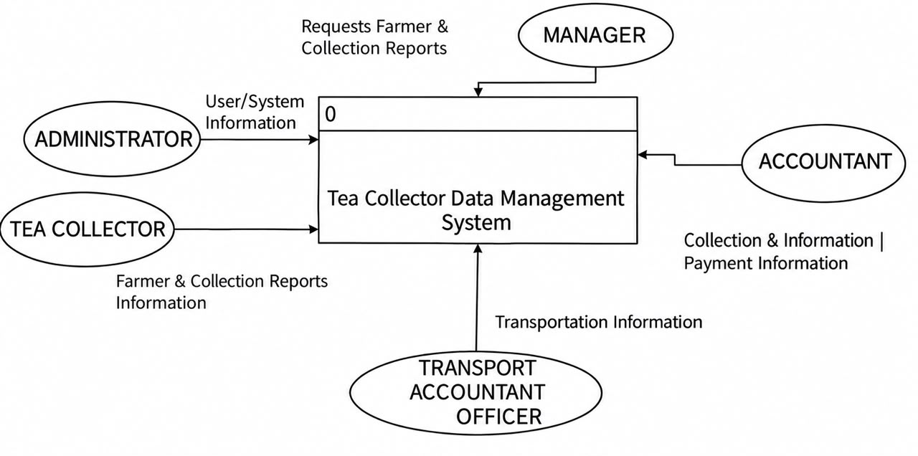
Figure 3: Context Diagram (DFD - Level 0) of the System

4.7.1.2. DFD - Level 1
A level 1 data flow diagram (DFD) is more detailed than a level 0 DFD. It breaks down the main processes into sub processes that can then be analyzed and improved on a more detailed level.
DFD-Level 1 of the system:
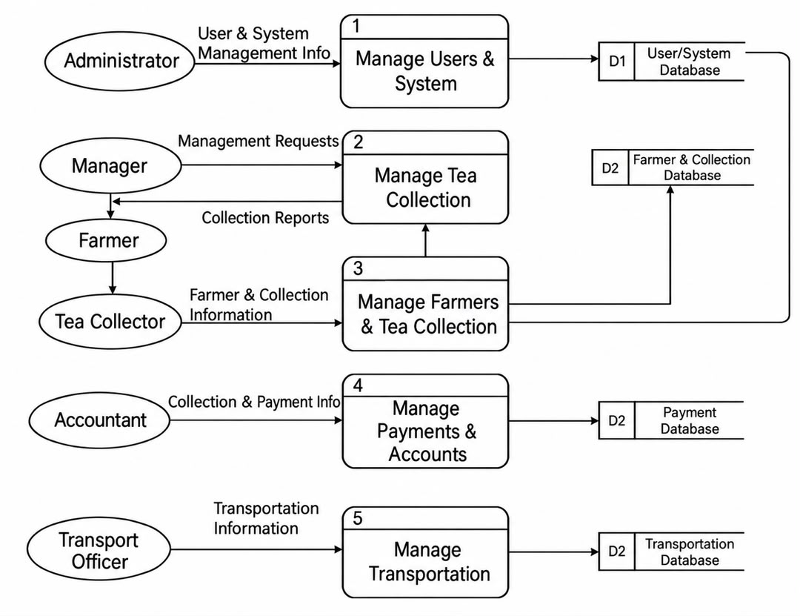
Figure 4: Data Flow Diagram Level 1 of the System

4.7.2 Use Case Diagram and sequence Diagrams
4.7.2.1 Use Case Diagram
A use case diagram is a dynamic or behavior diagram in UML. Use case diagrams model the functionality of a system using actors and use cases. Use cases are a set of actions, services, and functions that the system needs to perform. In this context, a "system" is something being developed or operated, such as a web site.
Basic Use Case Diagram Symbols and Notations
System: Draw your system's boundaries using a rectangle that contains use cases. Place actors outside the system's boundaries.
Use Case: Draw use cases using ovals. Label the ovals with verbs that represent the system's functions.
Actors: Actors are the users of a system.
Relationships: Illustrate relationships between an actor and a use case with a simple line. For relationships among use cases, use arrows labeled either "uses" or "extends." A "uses" relationship indicates that one use case is needed by another in order to perform a task. An "extends" relationship indicates alternative options under a certain use case. (Smartdraw, 2023)
Use Case Diagram of the system
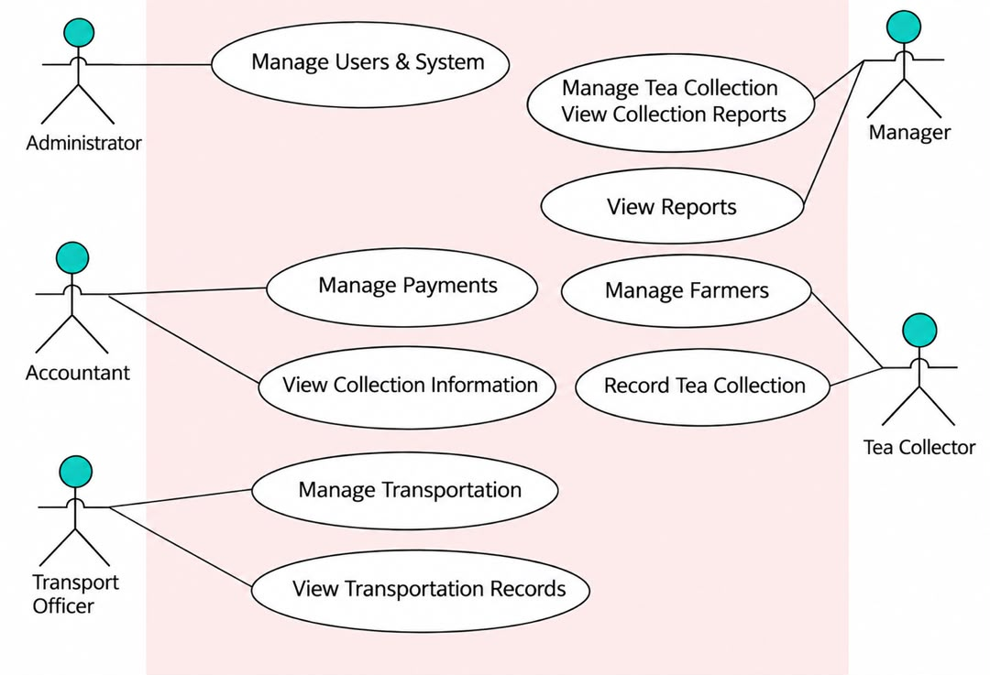
Figure 5: Use Case Diagram of the System

4.7.2.2. Sequence Diagram
A sequence diagram simply depicts interaction between objects in a sequential order i.e. the order in which these interactions take place.
Sequence Diagram Notations
1. Actors: An actor in a UML diagram represents a type of role where it interacts with the system and its objects. It is important to note here that an actor is always outside the scope of the system we aim to model using the UML diagram.
2. Lifelines: A lifeline is a named element which depicts an individual participant in a sequence diagram.
3. Messages: Communication between objects is depicted using messages. The messages appear in a sequential order on the lifeline. We represent messages using arrows. Messages can be broadly classified into the Synchronous and Asynchronous Messages. (GeeksforGeeks, 2022)
Uses of sequence diagrams
- Used to model and visualize the logic behind a sophisticated function, operation or procedure.
- They are also used to show details of UML use case diagrams.
- Used to understand the detailed functionality of current or future systems.
- Visualize how messages and tasks move between objects or components in a system.

Sequence Diagram of the system:
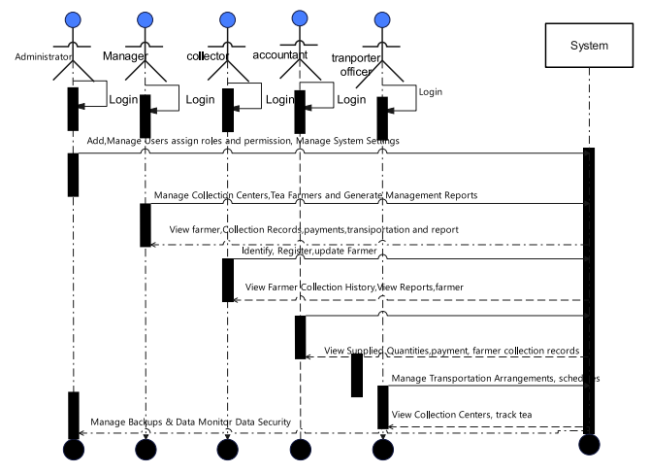
Figure 6: Sequence Diagram of the System

4.7.3 Data Dictionary
A data dictionary contains metadata i.e data about the database. The data dictionary is very important as it contains information such as what is in the database, who is allowed to access it, where is the database physically stored etc. The users of the database normally do not interact with the data dictionary; the database administrators only handle it.

- Table Name: Users (Table including Admin, Manager and Employee/collectors)
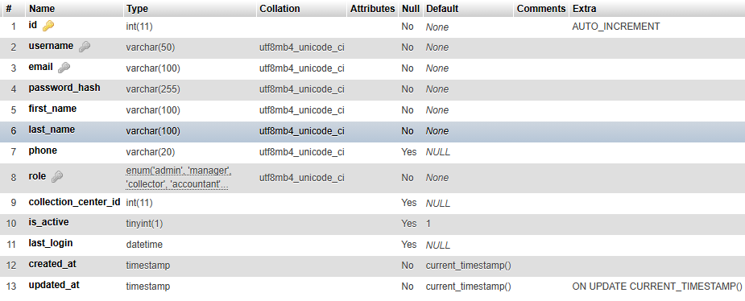
Table 5 manager and admin information
- Table Name: Collection centers (Table including collection centers)

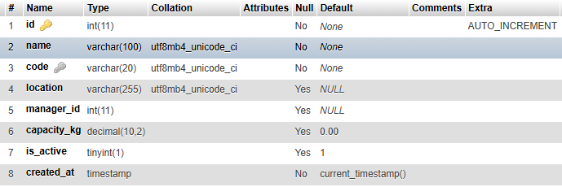
Table 6 collection centers
- Table Name: Farmers (Table including farmers)
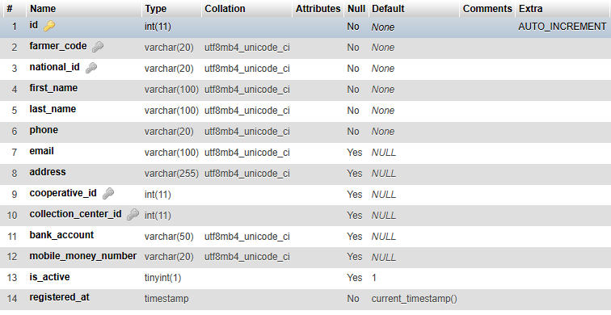
Table 7 farmers
- Table Name: Tea collections(Table including collection of tea)

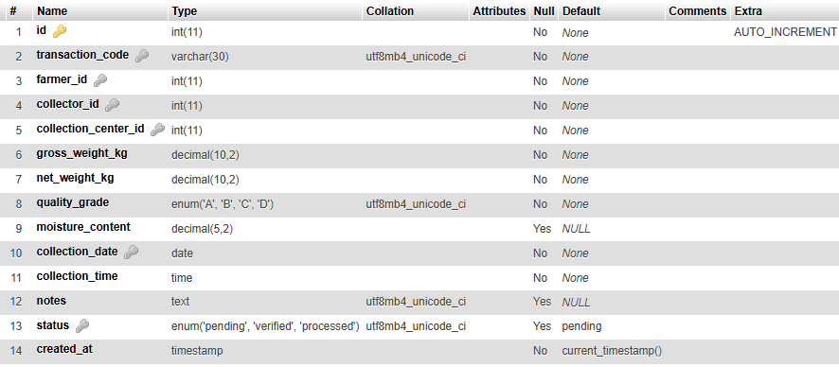
Table 8 tea collections
- Table Name: Vehicles (Table including vehicles information)
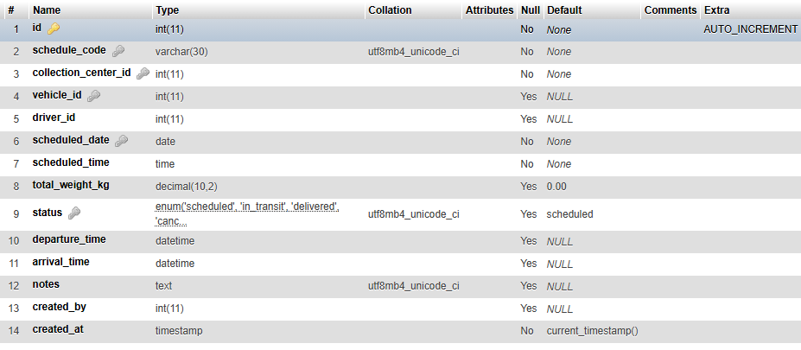
Table 9 Vehicles

- Table Name: Transport schedules (Table including transport schedule information)
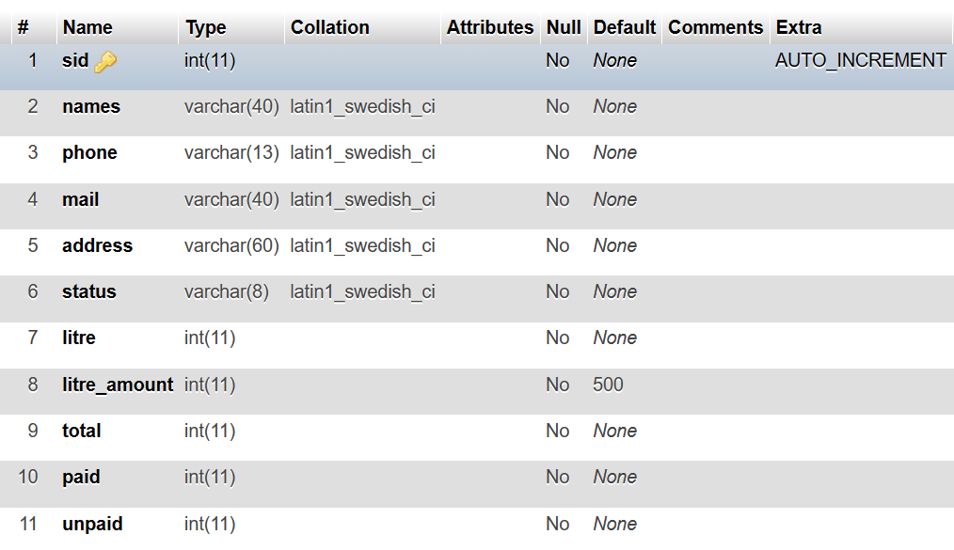
Table 10: Transport schedules

- Table Name: cooperatives(Table including all cooperatives)

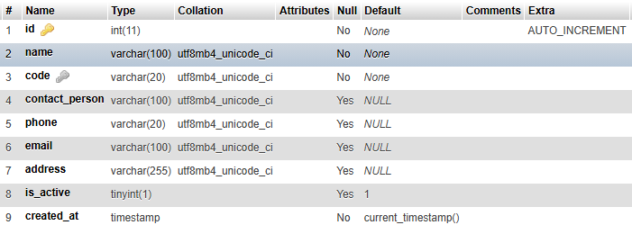
Table 11 cooperatives
- Table Name: Vehicles
Table 12 Vehicles

- Table Name: Inventory (Table including payment information)
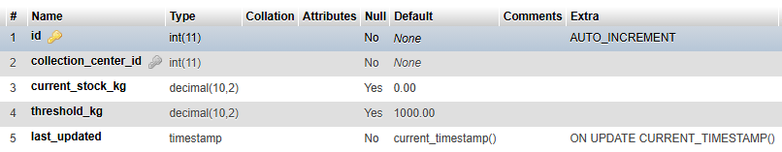
Table 13: inventory

4.7.4 Entity Relationship Diagram
An Entity Relationship (ER) Diagram is a type of flowchart that illustrates how “entities” such as people, objects or concepts relate to each other within a system. Also known as ERDs or ER Models, they use a defined set of symbols such as rectangles, diamonds, ovals and connecting lines to depict the interconnectedness of entities, relationships and their attributes. They mirror grammatical structure, with entities as nouns and relationships as verbs.
The components of an ER diagram
Entity: a definable thing such as a person, object, concept or event that can have data stored about it. Think of entities as nouns. Examples: student, car or product typically shown as a rectangle.
Relationship: how entities act upon each other or are associated with each other. Think of relationships as verbs. For example, the named student might register for a course.
Attribute: a property or characteristic of an entity. Often shown as an oval or circle.
Cardinality: defines the numerical attributes of the relationship between two entities or entity sets. The three main cardinal relationships are one-to-one, one-to-many, and many-many.
Cardinality constraints: The minimum or maximum numbers that apply to a relationship.

Entity Relationship Diagram (ERD) of the system

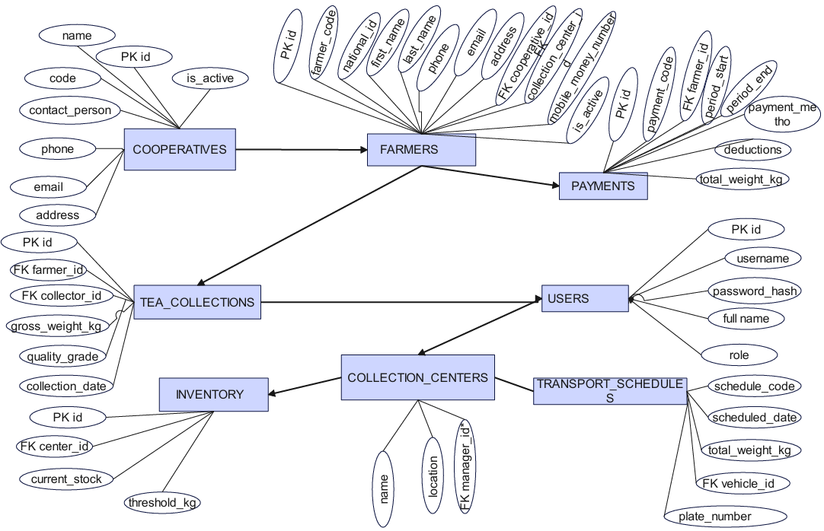
Figure 7 Entity Relationship Diagram

4.7.5 Physical Data Model
A physical data model represents the actual structure of a database tables and columns, or the messages sent between computer processes. Here the entity types usually represent tables, and the relationship type lines represent the foreign keys between tables.

Physical Data Model of the system

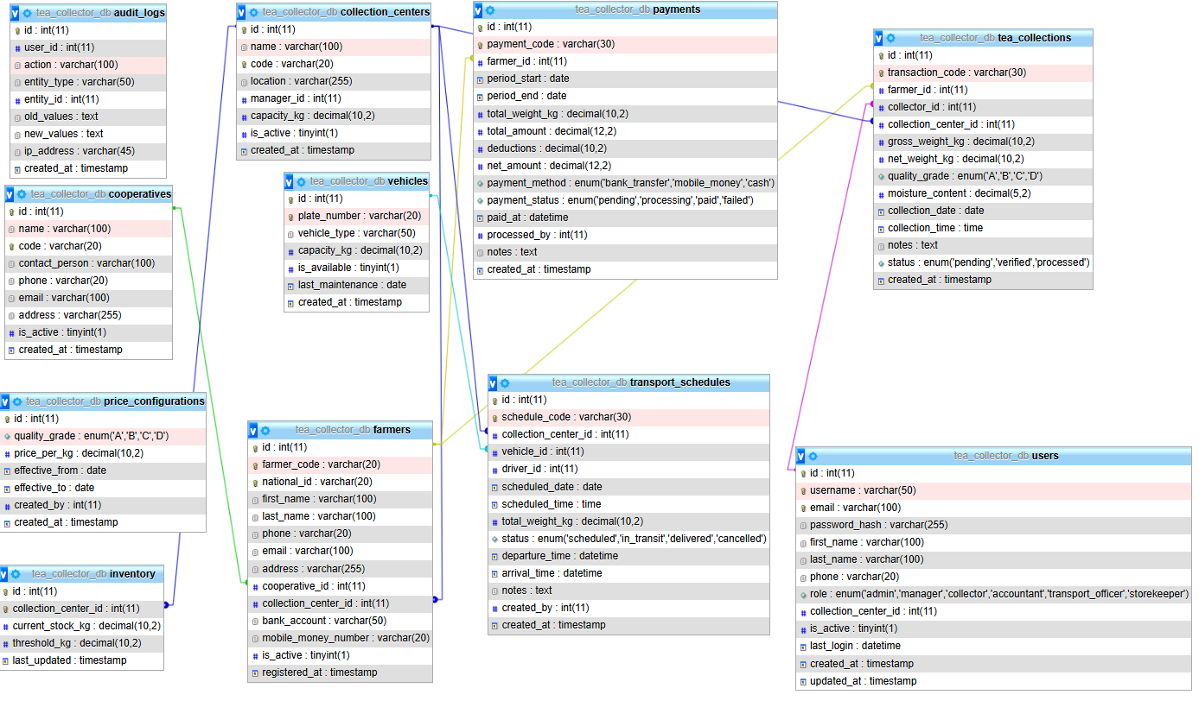
Figure 8: Physical Data Model of the system

4.8 Architecture design of the new System
A system architecture or systems architecture is the conceptual model that defines the structure, behavior, and more views of a system. An architecture description is a formal description and representation of a system, organized in a way that supports reasoning about the structures and behaviors of the system. It represents the structure of data and program components that are required to build a computer based system.
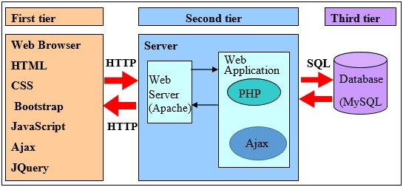
Figure 9 Architecture design of the new System

4.9 Implementation and coding

4.9.1 Introduction
This chapter details the creation of tea collection data Management System for managing tea collection center. It also contains information on coding, interfaces (screenshots), and the system's testing findings.

4.9.2 Description of implementation Tools and technology
PHP is an open source server side programming language that is frequently used for web scripts and to analyze data given via Common Gateway Interface from HTML forms, among other things.
This platform was created in PHP to connect with databases.

4.9.2.1 PHPMYADMIN

phpMyAdmin is a PHP-based web application that includes XHTML, CSS, and JavaScript client code, as do the majority of web apps. Its official home page may be found at http://www.phpmyadmin.net. Since its inception, it has been open source and has received assistance from several developers and translators all around the world.
phpMyAdmin is a component of the well-liked cPanel tool for managing websites. The purpose of phpMyAdmin is to provide comprehensive web-based control of MySQL servers and data while also keeping up with the development of both MySQL and web standards. (phpMyAdmin, 2024)

4.9.2.2 Visual Studio Code
Developers may work with many open files using Use this guide to install Visual Studio Code, open your code, and choose a hands-on path for your first task. You can learn the editor and write code yourself, use an AI agent, or combine both approach In addition, it offers syntactic folding and syntax highlighting for more than 50 scripting, markup, and programming languages, including HTML. It makes an effort to automatically determine the language that a given file uses by using a list of file extension bindings that can be modified, but you can also explicitly change the language. (Code, 2026)

4.9.2.3 MySQL

MySQL is an incredibly quick and reliable relational database management system (RDBMS). You can efficiently store, search, sort, and retrieve data using a database. The MySQL server manages access to your data to provide concurrent use by multiple users, quick access, and the restriction of access to just authorized users. Therefore, MySQL is a server with several users and threads. The preferred database query language is Structured Query Language (SQL). It is the most widely used open-source database in the world and has received the Linux Journal Readers' Choice Award numerous times.
MySQL is accessible through a dual license model. As long as you agree to abide by the conditions of the GPL open-source license, you are free to use it. (Roy, 2023)

4.9.2.4 APACHE

Apache is primarily used to serve both static content and dynamic Web pages on the World Wide Web. Many web applications are designed expecting the environment and features that Apache provides. Apache is the web server component of the popular LAMP web server application stack, alongside MySQL, and the PHP /Perl /Python programming languages.
Apache is used for many other tasks where content needs to be made available in a secure and reliable way. A user who has Apache installed on their desktop can put arbitrary files in the Apache's document root which can then be shared Programmers developing web applications often use a locally installed version of Apache in order to preview and test code as it is being developed. (K.S.Sampathkumar, 2010)

4.9.2.5 JavaScript

The researcher used JavaScript, a language created by Netscape, to enable Web designers to create interactive sites for performing the same system validations. Despite having many of the same features and structures as the entire Java Language, it was independently created. JavaScript may interact with HTML source code, allowing Web designers to add dynamic content to their websites.
For instance, JavaScript enables the updating of a web page's content in response to an event, such as when a user clicks a button. It also provides the ability to retrieve a user’s input and process that input. (John Dean, 2019)

4.9.2.5 What Is Bootstrap?
Mark Otto and Jacob Thornton, who both worked at Twitter when Bootstrap was first launched, created it as an open source project. From being a wholly CSS-driven project, it has developed to incorporate a variety of JavaScript plugins and icons that work in tandem with forms and buttons. One of the highlights of the Bootstrap website is the build tool, which allows you to tailor the build to your requirements by selecting the CSS and JavaScript features you wish to use on your website. With Bootstrap, all you need to do to get started is incorporate the bootstrap.css CSS file and, optionally, the bootstrap.js JavaScript file into your website. (Spurlock, 2013)

4.9.2.6 JQuery
For client-side web development, JavaScript frameworks have emerged as indispensable and practical allies. The gaps between standard and nonstandard were greatly filled by frameworks like jQuery. JQuery is currently the most widely used JavaScript framework and application development platform. A developer of JavaScript applications will find it simpler to use because it is smaller, faster loading, and packed with functionality. (York, 2015)

4.9.2.7 AJAX
An innovative tool for making user-friendly online applications is AJAX. However, it can be misused, just like any other technology, which could make things more difficult for users, ignore users with disabilities, or worsen search engine performance. Asynchronous JavaScript and XML is known as AJAX. Simply defined, AJAX provides a method to update specific parts of the website without requiring a complete page reload by utilizing JavaScript to conduct background server calls and retrieve extra data as needed. By enabling background communication between the client and server while the user is interacting with the page, AJAX eliminates the imbalance between the two. (Hendrix, 2009)

4.9.2.8 Hypertext Markup Language (HTML)
When creating web pages, we employ HTML, a presentational language. It is a descriptive language used to describe the organization, placement, size, and color of fonts in documents. HTML is not a programming language, and therefore cannot do programming-related tasks, not even the most basic program logic, like the addition operation, for example.
HTML pages are nothing more than simple text files. Includes a .html extension and page display instructions. They can be created in any text editor, such as Notepad, because they are just text files. Naturally, there are more sophisticated variations of visual editors, also referred to as WYSIWYG editors (what you see is what you get) editors. During the creation of a web page, these editors offer the capability to show the page layout.
We use marked tags, which are written between < >, to define a web page. Each tag acts as a command, instructing the browser on what to do and how to present the material. (Maini, 2015)

4.9.2.9 Cascading Style Sheets (CSS)
The W3C standard for defining the display of documents produced in HTML, and actually any XML language, is called Cascading Style Sheets (CSS). Once more, presentation describes how a document is shown to the user, whether it is through printing on paper, reading aloud by a screen reader, displaying on a computer or mobile device, or any combination of these. HTML may take care of the business of defining document structure and meaning, as intended, while style sheets manage the presentation. CSS has its own syntax and is a distinct language.
All significant browsers now implement CSS3, the most recent version of the standard. The W3C began work on CSS4 in 2009. Unfortunately, the main browsers still do not fully implement CSS4. A style sheet consists of one or more style instructions (also known as rules or rule sets) that specify how to display a certain element or collection of elements. Being acquainted with the components of a rule is the first step in understanding CSS. Each rule declares the appearance of an element after choosing it. (Robbins, 2012)

4.9.2.10 Browsers
Now that we are aware that the server performs the serving, how about the other component? The client is the piece of software that requests things. People access documents on the Web using desktop browsers, mobile browsers, and other assistive technologies (like screen readers) as clients. The user agent, commonly known as the browser in technical jargon, receives the content from the server to display.
It is typical to picture a browser as a window on a computer screen that shows a web page. These were the only options for accessing the web for a very long period. They are also referred to as desktop browsers. As of this writing, Internet Explorer for Windows, Chrome, Firefox, and Safari are the most widely used desktop browsers, with Opera coming in last.
Users with vision impairments may use a screen reader to read a website aloud to them (or simply make their text extremely large). Users with limited mobility can type on and access links using assistive technology. No matter their level of web experience, all users must be able to access and use the sites we create. Pages may seem and function differently from browser to browser, even on the desktop browsers that first exposed us to the Web. (Robbins, 2012)

4.9.2.12 PHP
The acronym PHP stands for Hypertext Preprocessor. A scripting language for HTML websites is called PHP. The HTML file's embedded code is executed by the server. PHP is typically used when a programming language is integrated with MySQL. This is because PHP and MySQL provide almost ideal conditions for developing dynamic websites: easy deployment, rapid performance, and unbeatable price.
There are two MySQL programming interfaces available as of PHP 5. Many PHP programmers are familiar with the mysql functions from prior versions of PHP. The object-oriented interface mysqli, which debuted with PHP 5, offers more sophisticated programming features and access to new MySQL methods. However, mysqli expects that you have MySQL 4.1 or newer and PHP 5 accessible. (Kofler, 2005)

4.9.3 Screen Shots and Source Codes
The system is made up of three modules, one that deals with administration of system, administrator log in to the system in order to access his/ her functions, which include administering the system in its entirety. Manager is responsible for managing the users, accountant, tea collector, farmer and employee of sorwathe Ltd, facilitating them to handle the issues related to check expiration product, approve farmer pay. User access the system to record product, milk entry and managing, provide report to the sorwathe Ltd. Screenshots of the system's primary pages are displayed below:

4.9.3.1 Welcome Page
This is the welcome page of the system that will be firstly accessed by any user after typing the web address in the address bar of any browser. This page contains login account, privileged users.
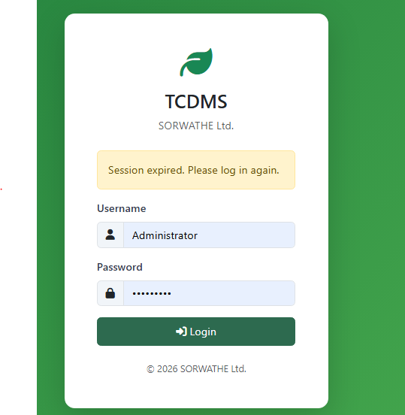

Figure 10: Welcome Page

4.9.3.2 Administrator Dashboard
This page contains the form that help administrator to privileged access page.

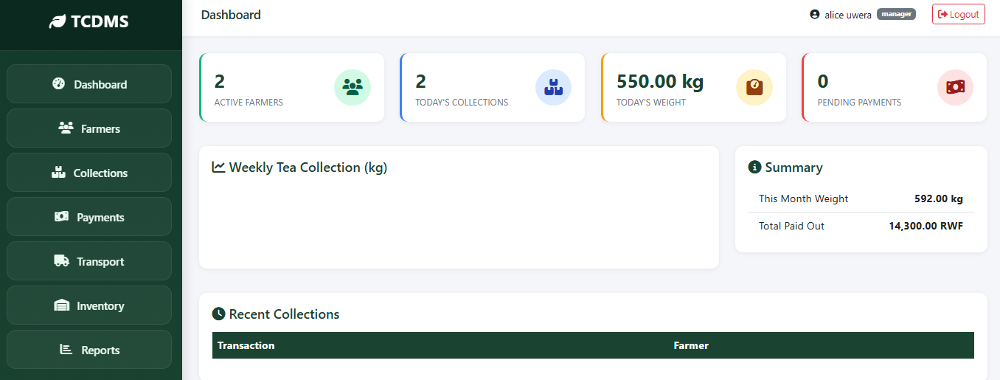
Figure 11: Admin Dashboard

4.9.3.3 Register Collector/ User, Accountant, Transport officer or Manager by Administrator
This page contains the form that help administrator to create account of manage and user on system, after account created user and manage has access right to the system.

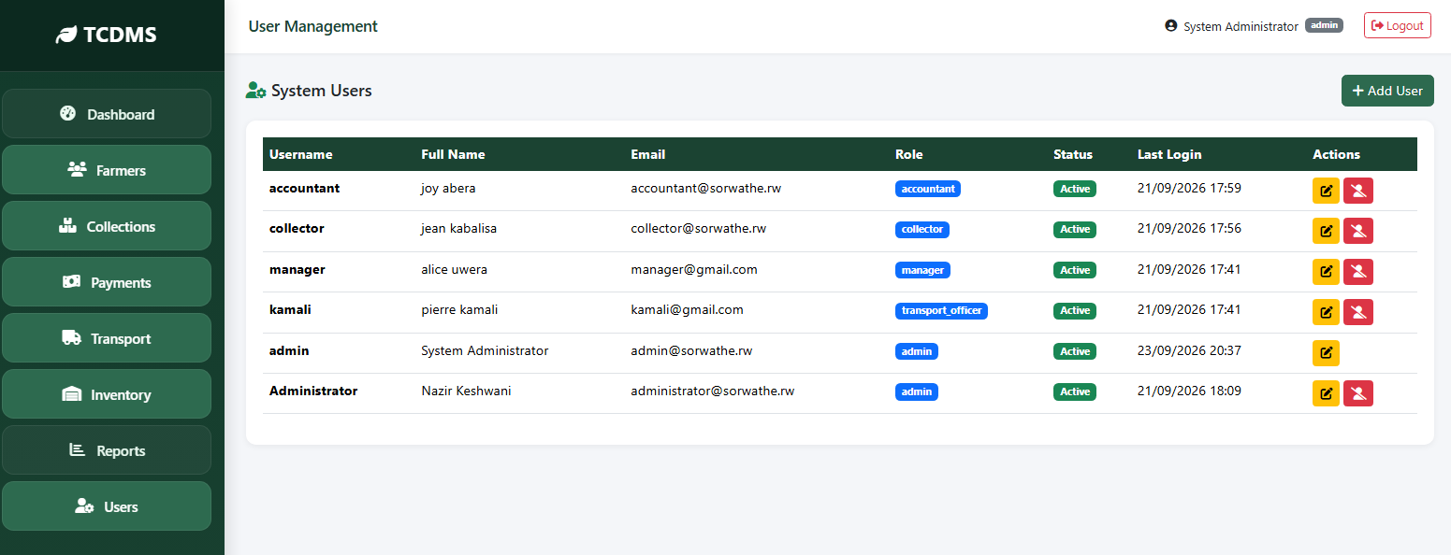
Figure 10 Register User or Manager by Administrator

4.9.3.4 After Manager Login
This page contains the form that is used by system user to login to system where each category of user has privileges different from others. The authorized user login to the system by issuing appropriate Username and password.

Figure 11 Login users form

4.9.3.5 Manage farmer
This page is us to manage farmers
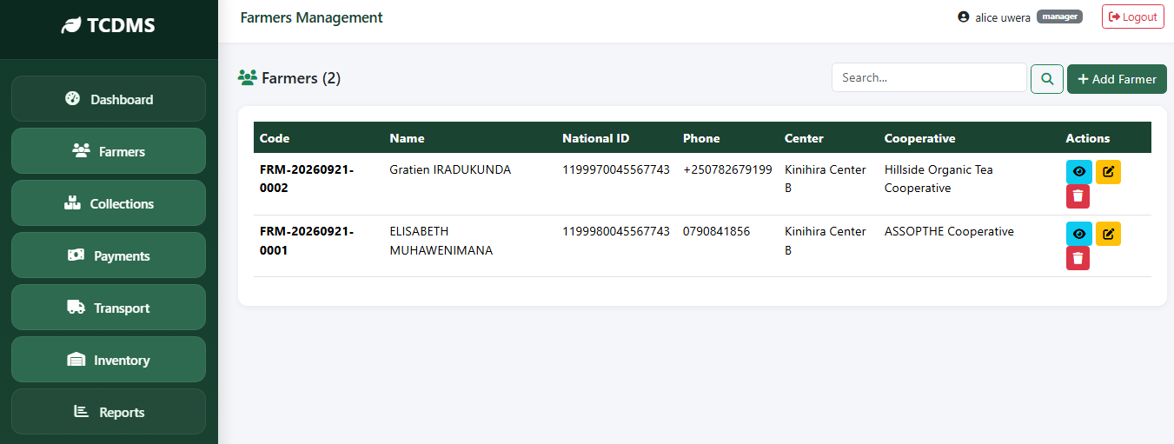

Figure 12 manage farmers

4.9.3.6 Manage collections tea
This page is page display collection list and status process.
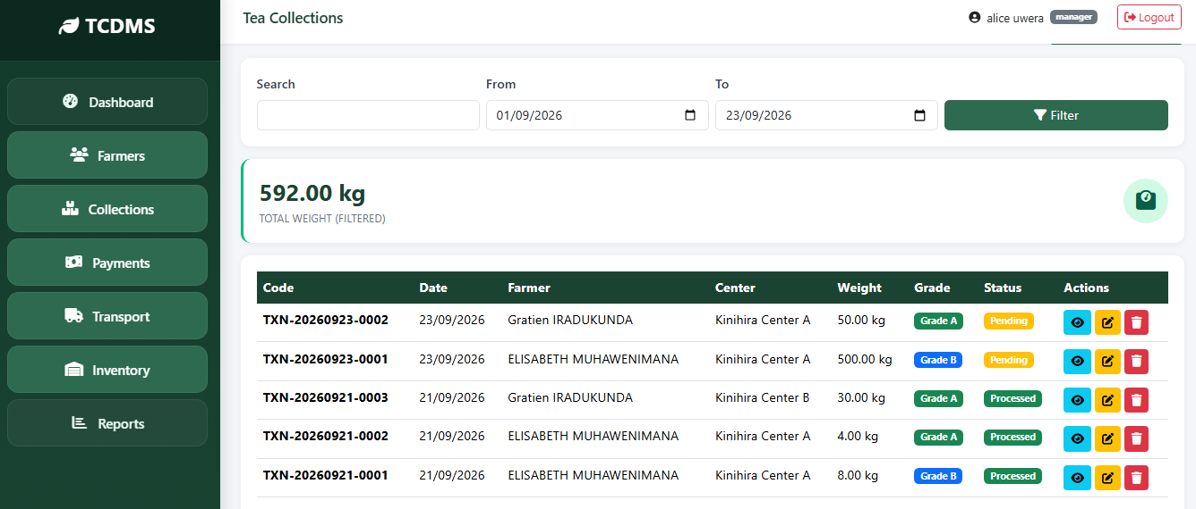

Figure 13 Collection manage

4.9.3.7 Manage payment
This page is viewing payment status.
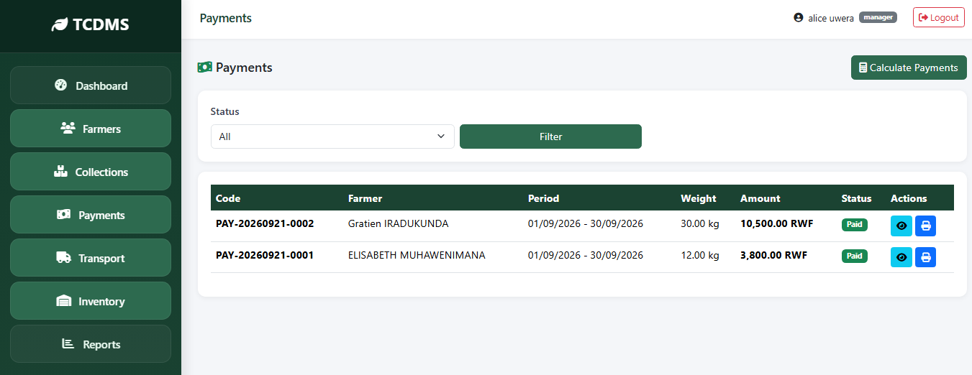
Figure 14 payment manage and status

4.9.3.8 Tea collection inventory
This page is display inventory.
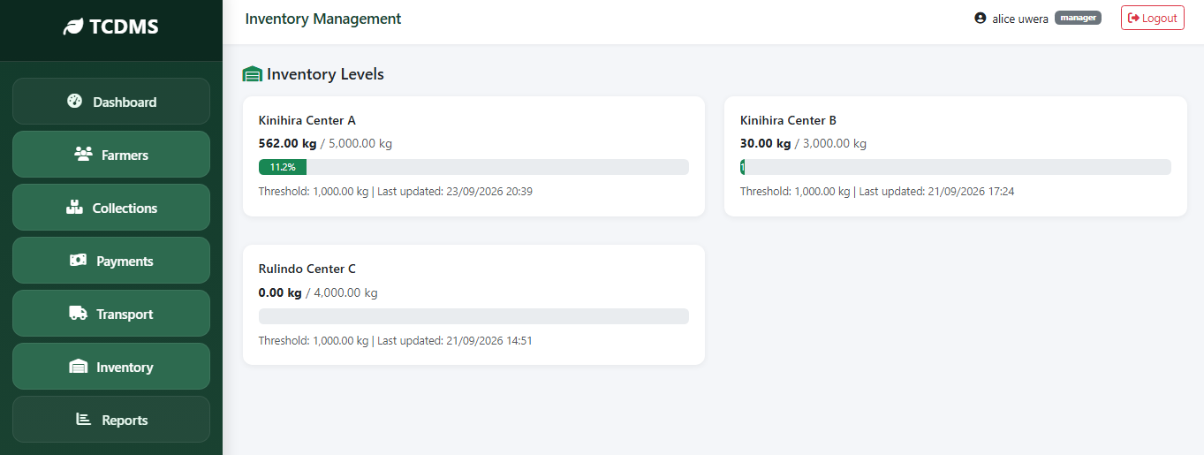

Figure 15 tea collection inventory

4.9.3.9 Manager Report
This page contains the manager report export link.
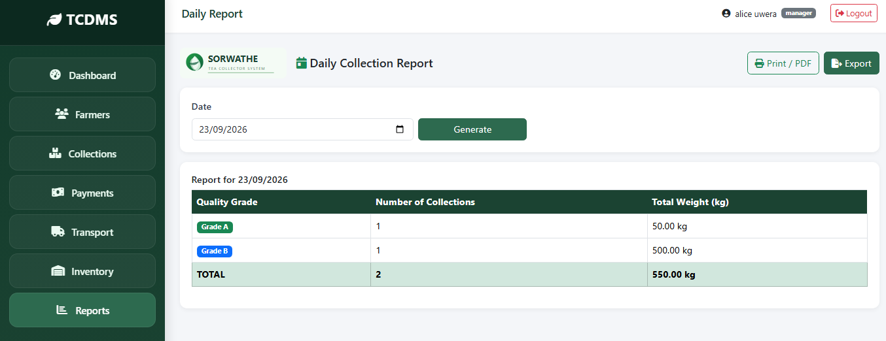
Figure 16 manager report

4.9.3.10 New record of Tea collection page by collector
This page contains the form that help collector to record tea collection.
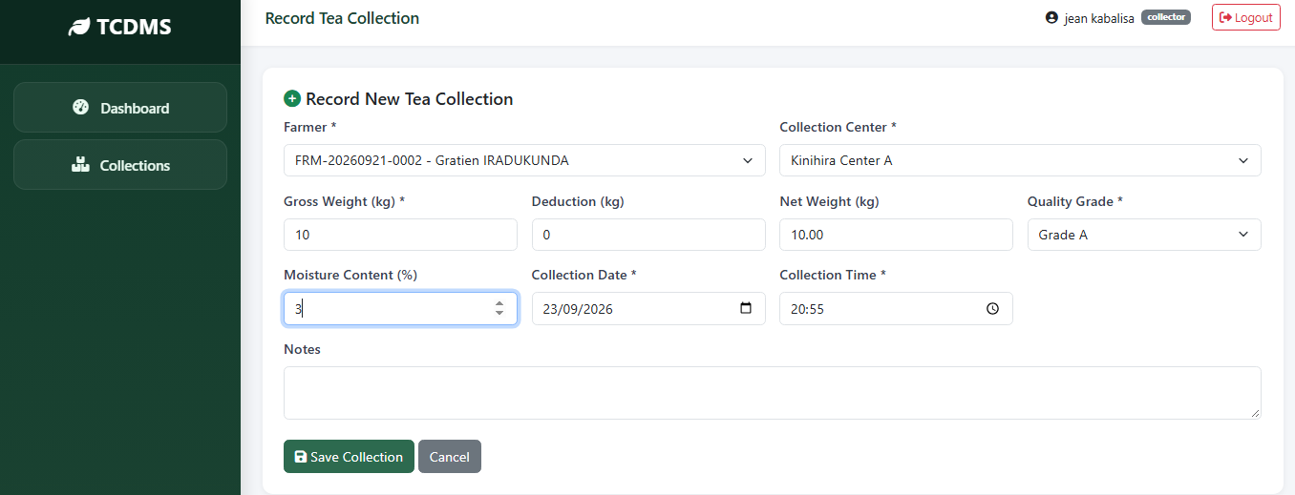
Figure 17 New record of Tea collection page by collector

4.9.3.11 Transport schedule and add new
This page of Transport schedule and add new.
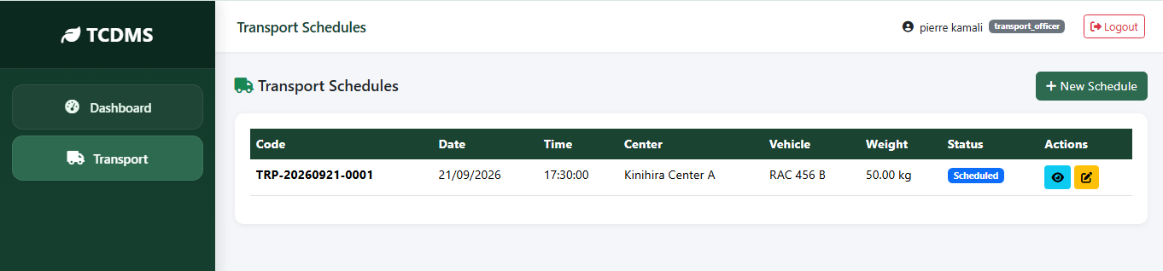
Figure 18 Transport schedule

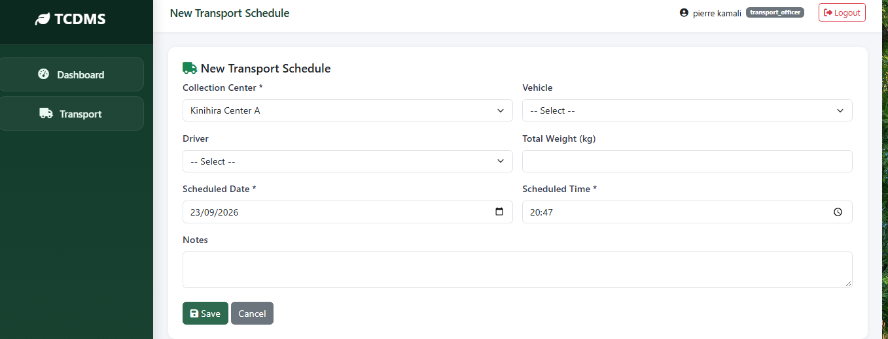
Figure 19 Transport new schedule

Figure 20 manager report

4.9.3.12 View and calculate payment by accountant
This page contains the form that help accountant to calculate payment record.
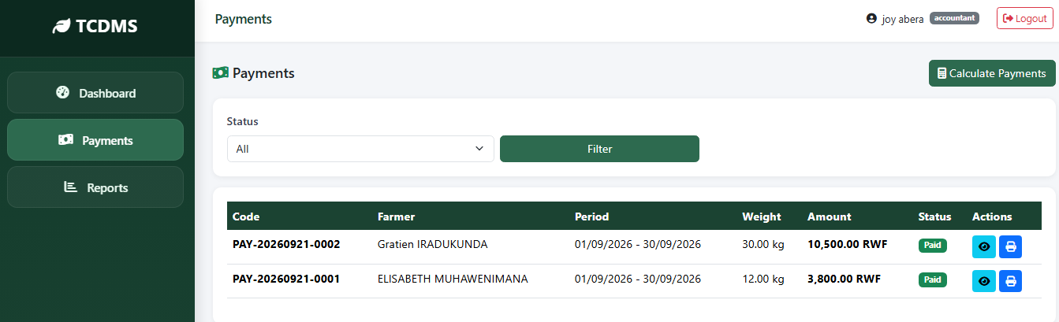
Figure 21 View and calculate payment by accountant

4.9.3.13 Reporting by accountant
This page of Transport schedule and add new.
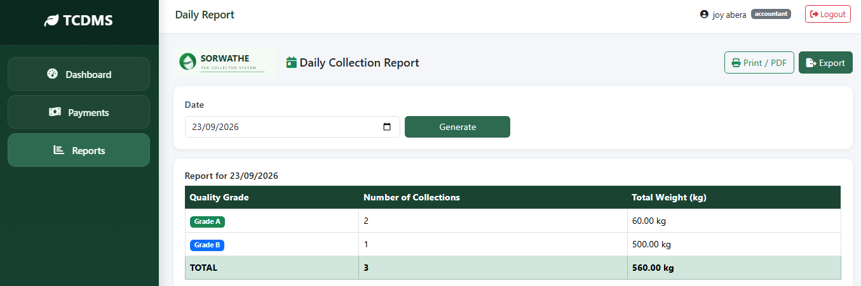
Figure 22 reporting by accountantt

4.10 Testing

4.10.1 Introduction
The primary quality assurance technique used in software development is testing. Software error detection is a fundamental feature. After the coding process, there are computer programs that can be used for evaluating the output of the requirement analysis and design document, which is typically textual and non-executable. This suggests that testing must find flaws that were not present in the prior phase. Finding requirements, design, and code faults in the software is the aim of testing.

4.10.2 Objective of Testing
The goal of the testing procedure is to find every flaw in a piece of software. Any activity called testing aims to assess the software's ability to manage and provide high-quality outcomes. Testing is a procedure to find discrepancies between the desired outcome and the actual outcome.
Testing establishes whether it appears that, the system is operating in accordance with the requirements. It is the stage where we attempt to undermine the system and, at one point, test it using actual case studies.

4.10.3 Unit Testing Outputs
After being coded and accepted, a module has undergone unit testing. Unit testing is the process of individually testing different system parts or units. Unit testing is advantageous because it makes debugging easier, which is the responsibility of the programmer, before integration testing. If a bug were to be found while testing multiple modules at once, it would be difficult to identify exactly which module it is.
The current "Tea collection data Management System" only does unit testing upon the completion of each module.

4.10.4 Validation Testing Outputs
Validation Testing makes ensuring that the product truly satisfies the needs of the employees. It is also possible to describe it as proving that a product works as intended when used in the right setting. Is the product we are creating the right one? Is answered by this statement.
All validations were performed during the development of this suggested system to guarantee that it satisfied user needs and that the test's output was reliable. The system has undergone successful testing to guarantee that it operates properly and effectively.

4.10.5 Integration Testing Outputs
Once a program or module has undergone unit testing, the programmer can begin working on integration. Integration testing's primary objective is to test the module interfaces to ensure that there are no issues with parameter passing when one module communicates with another. The various system components are put together in the order that they will be put together to build the whole system during integration testing.
The many integration testing methods include:
- Big Bang Approach.
- Top-Down Approach.
- Bottom-Up Approach.
- Mixed Approach.
The Mixed Approach has been adopted for this system out of the four methods mentioned above. A top-down and bottom-up testing approach are both used in a mixed approach integration test. Testing can only begin using the top-down methodology when the top-level modules have been created and put through unit tests. Similar to this, the bottom-up technique cannot begin until the bottom-level modules are complete. These top-down and bottom-up approaches' drawbacks are overcome by the mixed approach. Testing can begin as an in the mixed testing strategy when modules are made available.
The produced system passed the aforementioned testing with excellence.

4.10.6 Functional and system testing Results
System testing is essentially a collection of many tests that are all designed to exercise a computer based system. They are all undertaken to ensure that system components have been correctly linked and have carried out their designated functions. Finding out whether a particular functionality operates as expected is the goal of functional testing.
Its main goal is to demonstrate that the finished system functions as intended. This test is administered in a professional manner. The testers employ scenario-based, output-predicted system test scripts.
Structured test logs are used to document the test findings. Structured test logs and scripts guide the system testing process. The purpose of system testing is to demonstrate that the system achieves its goals. Testing demonstrates that the system satisfies the specifications. This is not very accurate unless acceptance testing is viewed as a particular kind of system testing because its goal is to show that the system satisfies the user's requirement. The process of validation is acceptance testing.
In the purest sense, system testing is a verification procedure. System testing represents an outside view of the system, regardless of whether it represents validation or verification. This is accurate because requirements indicate the system's potential users (an external view). Users do not care or understand how a system operates as long as it is functional. This angle should be taken when conducting system testing.
These criteria are met by the "Tea collections data Management System" that is being. The user is the outcomes after testing the suggested TCDMS. This displays the user-configured functionality that is available in the TCDMS.
No | Functionality | Description | Status
1 | Login Admin | Method to login process based on admin database | OK
2 | Login Manager | Method to login process based on Manager database | OK
3 | Login collector, accountant | Method to login process based on user database | OK
3 | Create users | Method to add a new user into the database | OK
4 | Record tea quantity | Method to tea record from farmer | OK
5 | Schedule transport | Method make schedule in system | OK
6 | Calculate payment | Method to calculate payment and display status of payment | OK
7 | Provide report | Method of reporting | OK

4.10.7 Acceptance Testing Report
Acceptance testing is a type of testing used to evaluate whether or not the software system satisfies the requirements. This test's primary objective is to assess the system's adherence to the system requirements and determine whether it has satisfied the standards necessary for delivery to end users.
The results of the acceptance test cases are compared with the anticipated ones after they have been run against test data or utilizing an acceptance test script. By keeping users informed of the development process and adopting any improvements they recommended, the technology under consideration was continually tested for user acceptance. A small group of volunteers were requested to thoroughly test the program and score their interactions with it after all requirements had been met and a useful piece of software had been produced.

CHAPTER 5 CONCLUSION AND RECOMMENDATIONS

5.0 Conclusion
To conduct this research study, the reference was made to discussion related to the management of sorwathe ltd. This model of system is not trusted because sometime data lost, the made decision is that the employee have to be given the information of product. By referring to that decision I decided to conduct the research to this model of management, according to the research results I was committed to develop computerized system that facilitate data recording, management of product and expiration monitoring.
To develop the system, I considered functionalities that should be performed in manual system so that the system meets the users’ need. This system not only include the function of product management also farmer detail and record. Farmers can get their money via a system manager approve.
After developing system, it was tested to ensure that is meeting the users’ need and it is running correctly without errors where each module was tested and finally the entire system was tested successfully. According to the research problem, the developed system can replace the existing manual system to solve the problems caused that old system.

5.2 Recommendations
In our country, different sectors implement computerized system to process the activities in tea collection data management and store information to increase the productivity and solving different problem existing in the manual system. As the developed system is a solution to the discussed system model known as tea collection data management system, I recommend the citizens to adopt this developed system and continue encouraging others to use it in order to acquire its advantages. Also I recommend to students of university of Kigali to find the gap in my research if any and then conduct their research in order to cover it.

References
Agri-plantation, R. (2026, june). digital-transformation-for-smallholder-tea-plantation. Retrieved from https://softweb.co.in/: https://softweb.co.in/blog/digital-transformation-for-smallholder-tea-plantation/
altexsoft. (2018). functional-and-non-functional-requirements-specification-and-types. Retrieved from altexsoft: https://www.altexsoft.com/
C. Umutoni, I. N. (2023, march). Prediction of Tea Production in Rwanda Using Data Mining Techniques. Retrieved from https://www.researchgate.net/: https://www.researchgate.net/publication/371796007_Prediction_of_Tea_Production_in_Rwanda_Using_Data_Mining_Techniques
G.K.A, B. (2022, october). https://ijemr.vandanapublications.com. Retrieved from www.ijemr.net : https://ijemr.vandanapublications.com/index.php/j/article/view/938/820
Garu99. (2023, october 28). non-functional-requirement-type-example.html. Retrieved from guru99: https://www.guru99.com/
GeeksforGeeks. (2022, May 6). https://www.geeksforgeeks.org/unified-modeling-language-uml-sequence-diagrams/. (Simmytarika5, Editor, D. P. UML, Producer, & GeeksforGeeks) Retrieved October 15, 2022, from https://www.geeksforgeeks.org/: https://www.geeksforgeeks.org/unified-modeling-language-uml-sequence-diagrams/
Igara Tea Growers Factory, U. (2018, December). Data-driven smallholder tea production in Uganda. Retrieved from https://cgspace.cgiar.org: https://cgspace.cgiar.org/items/8801a829-4752-41fd-b3e2-c9b6963011d0
Indeed-Team. (2021, June 2). https://www.indeed.com/career-advice/career-development/what-is-uml. Retrieved October 12, 2022, from https://www.indeed.com: https://www.indeed.com
Javatpoint. (2026, july 24). Iterative model. Retrieved from Iterative model: https://www.javatpoint.com/software-engineering-iterative-model
Karunarathna, C. (2025, july). Importance of IT in Today's World. Retrieved from https://www.scribd.com: https://www.scribd.com/document/826588066/The-Importance-of-Information-Technology-in-the-Modern-World
Kola, M. (2020, june). EVALUATION OF WASTE MANAGEMENT SYSTEMS. Retrieved from https://www.researchgate.net/: https://www.researchgate.net/publication/366046063_EVALUATION_OF_WASTE_MANAGEMENT_SYSTEMS_IN_A_KENYAN_TEA_FACTORY_A_CASE_STUDY_OF_MARAMBA_TEA_FACTORY_IN_KIAMBU_COUNTY
Mogere, K. M. (2013, november 30). Effect Of Inventory Control Systems On Operational Performance Of Tea Processing Firms. Retrieved from https://internationaljournalcorner.com: https://internationaljournalcorner.com/index.php/theijbm/article/view/127777
Naeb. (2025). rwanda-tea. Retrieved from https://www.naeb.gov.rw: https://www.naeb.gov.rw/rwanda-tea
Piazza, L. (2025, 01 31). Tea supply chain, Environmental sustainability challenges, Divergent economies. Retrieved from https://www.researchgate.net/: https://www.researchgate.net/publication/389935879_The_tea_supply_chain_a_comparative_analysis_of_environmental_sustainability_challenges_in_divergent_economies
Research, L. (2012). Total population sampling. Retrieved from https://dissertation.laerd.com: https://dissertation.laerd.com/fundamentals/research-strategy/sampling/total-population.php
Roy, D. (2023, january 25). MySQL. Retrieved from MySQL and Its Use Cases: https://byte.builders/blog/post/mysql-and-its-use-cases/
Shikokoti, H. (2026, january). DATA_COLLECTION_METHODS_VALIDITY_AND_RELIABILITY_AND_STATISTICAL_METHODS. Retrieved from https://www.researchgate.net: https://www.researchgate.net/publication/400093807_DATA_COLLECTION_METHODS_VALIDITY_AND_RELIABILITY_AND_STATISTICAL_METHODS
Shubhampatni. (2020, May 26). https://www.geeksforgeeks.org/what-is-dfddata-flow-diagram/. Retrieved October 12, 2022, from https://www.geeksforgeeks.org/: https://www.geeksforgeeks.org/
Smartdraw. (2023, july 18). https://www.smartdraw.com/use-case-diagram/. Retrieved October 13, 2022, from https://www.smartdraw.com/: https://www.smartdraw.com/use-case-diagram/
sorwathe. (2024). about. Retrieved from https://sorwatheltd.rw/: https://sorwatheltd.rw/about/
sorwathe. (2026, june 01). About. Retrieved from https://sorwatheltd.rw: https://sorwatheltd.rw/about/
SORWATHE. (2026). the-impact-of-fairtrade-sorwathe. Retrieved from https://sorwatheltd.rw: https://sorwatheltd.rw/the-impact-of-fairtrade-sorwathe/
sorwatheltd. (2024). the-impact-of-fairtrade-sorwathe. Retrieved from https://sorwatheltd.rw/: https://sorwatheltd.rw/the-impact-of-fairtrade-sorwathe/
teaboard. (2023). GREEN LEAF QUALITY REQUIREMENTS FOR THE KENYA. Retrieved from https://www.teaboard.or.ke: https://www.teaboard.or.ke/images/downloads/Greenleaf-Quality-Requirements-for-the-Kenya-Industry.pdf
VisualParadigm. (2021, 12 08). guide/uml-unified-modeling-language/what-is-uml/. Retrieved from visual-paradigm: https://www.visual-paradigm.com/

